Nenahnezad Community School
Emergency Management Plan

Nenahnezad Community School
PO Box 337
Fruitland, New Mexico, 87416
505.960.6922

Everyone is a teacher in the pursuit of lifelong learning.
List of Revisions

Revision Number | Purpose / Change | Author | Date
1* | Update for FY2024 requirements and staff changes | Dr. David Smith | August 1, 2024
2 | Complete revision including SRP (I Love You Guys Foundation) | C. O’Banion | September 5, 2025
3 | Update for staff changes | C. O’Banion | July 2026
*The definitive original of this document is the electronic version [housed in the OneDrive/SharePoint of the current principal.] Any physical copies produced from this digital file are considered duplicates.

The use of the Standard Response Protocol and Standard Reunification Method is registered under MOU with the I Love You Guys Foundation and Nenahnezad Community School – September 2025

© Copyright 2006-2024, All Rights Reserved. The "I Love U Guys" Foundation, Conifer, Colorado. "I Love U Guys" Foundation, The Standard Response Protocol, The Standard Reunification Method and The Standard Distribution Method are Trademarks of The "I Love U Guys" Foundation and may be registered in certain jurisdictions.
Table of Contents

Section 1: Introduction
Section 2: Emergency Management Team Members
Section 3: Prevention and Preparedness
Section 4: Detection and Communications
Section 5: Evacuations and Reunification
Section 6: Incident-Specific Protocols
Appendices:
Appx A: maps
Appx B: Outdoor Air Quality Response

Section 1:

Introduction

Each year, children are placed at risk by a variety of hazards.
Assaults. Tornadoes. Hurricanes. Fires. Even mass shootings. These and other man-made and natural emergencies have created a new understanding of the need for emergency preparedness.
These procedures are designed to enhance school security for all students, staff, volunteers, and visitors and to assist the school in preventing, detecting, responding to, and recovering from emergencies. Staff members are required to follow them.
Authorities
Federally funded schools must abide by various federal directives, orders, and regulations that require emergency planning, a mandate amplified after the terrorist attacks of 9/11. These directives are detailed in the Continuity of Operations Plan for Indian Affairs, Regional Office, which serves as the overarching authority for this document. A key mandate is the implementation of the National Incident Management System (NIMS) required by Homeland Security Presidential Directive 5, Management of Domestic Incidents. The NIMS provides a unified approach to managing emergency incidents and standardizes command and communication protocols. Other federal authorities include:
- Homeland Security Presidential Directive 8, National Preparedness

- Executive Order 13347, Individuals with Disabilities in Emergency Preparedness

- 41 U.S. Code of Federal Regulations 101-20, Management of Buildings and Grounds

- 444 U.S. Department of the Interior Manual 1, Physical Protection and Building Security

- 375 U.S. Department of the Interior Manual 19, Information Technology Security

Partnership
Nenahnezad Community School has many partnerships especially when it comes to safety. We are proud to partner with the Bureau of Indian Education Safety, Navajo Nation Tribal Police and the San Juan County Safe Schools Committee to develop procedures and best practices.
For our response protocol to emergencies, the school will follow the Standard Response Protocol that has been developed and revised by the I Love You Guys Foundation.
We are also partnering with the Sandy Hook Promise to provide education and anonymous reporting support to us and surrounding schools (not to mention thousands of schools around the country).
Document Organization
This document provides general protocols for emergencies, such as communication and evacuation plans, and instructions on how to respond to specific types of emergencies. The latter are called incident-specific protocols. The list is not all-encompassing. Staff should use best judgment to provide for the safety of all personnel when unique events occur.

Types of Emergencies
Emergencies - also called hazards, threats, or incidents - are typically divided into man-made and natural. The following are examples:

MAN-MADE EMERGENCIES

Accidents
Bomb Threats
Cyber Crime
Fires
Fraud
Medical Emergencies
Riots
School Violence
Bullying
Assaults and Batteries
Gangs
Homicides
Hostage Situations
Shootings
Weapons
Substance Abuse
Sexual Predators
Suicide
Terrorism
Utility Failures

NATURAL EMERGENCIES

Animal Attacks
Blizzards
Earthquakes
Floods
Forest Fires
Landslides
Hurricanes
Tornadoes

Section 2:

Emergency Management Team Members
Understanding who will plan the emergency effort and who will lead school operations during an emergency is critical. Assigning roles and responsibilities ensures that required tasks are accomplished, reduces the chaos of the emergency scene, and eliminates duplication of effort. This section identifies the roles and responsibilities of staff members before, during, and after an emergency.

School Administration
The administration is responsible for providing leadership on security issues, selecting the Safe Schools Committee, approving security and emergency management procedures, updating contact information, receiving and acting on notifications of incidents, reporting incidents to the OIEP Chain of Command, bringing in external resources, establishing discipline procedures, following through with consequences in a fair and consistent manner, reporting serious incidents to parents or appointing a designee to do so, and other critical tasks.

TITLE | NAME | OFFICE PHONE | HOME PHONE/CELL | EMAIL ADDRESS
Principal | Vickie Blackwater | 505-960-6922 x224 | W 505-801-0390  H 505-442-2292 | Vickie.blackwater@bie.edu
Facilities | Ryan Sabaque | N/A | H 505-436-9084 | Ryan.sabaque@bie.edu
Security | N/A
School Counselor | Clifton O’Banion | 505-960-6922 x243 | W 505-329-1013  H 518-775-0868 | clifton.obanion@bie.edu
EPA | Rena Yazzie | 505-368-3408 | 505-422-3973 | Rena.yazzie@bie.edu

Safe Schools Committee
The Safe Schools Committee leads the Safe Schools planning effort. It fulfills the following purposes:
- It gives a specific group of people the responsibility for developing and updating the security plan and for ensuring it is implemented in an organized manner. It also shares the tasks required to assemble the plan among multiple individuals.
- It facilitates and formalizes communication among stakeholders who share a role in Safe Schools issues and provides a means to solicit diverse viewpoints.
- It serves as a vehicle to field complaints, compliments, and suggestions about security and to collect and analyze intelligence about emerging security threats such as the growing power of a new gang or a recent designer drug.
- It demonstrates to students, staff, and parents the administration’s commitment to ensuring a safe school and its diligence in addressing security issues.
- It provides an ongoing tool to assess existing security measures and to recommend new measures.

Safe Schools Committee Members (SY 2026-27)

TITLE | NAME | OFFICE PHONE | HOME PHONE/CELL | EMAIL ADDRESS
PRINCIPAL | Vickie Blackwater | 505-960-6922 x224 | W 505-801-0390  H 505-442-2292 | Vickie.blackwater@bie.edu
FACILITIES | Ryan Sabaque | N/A | H 505-436-9084 | Ryan.sabaque@bie.edu
SECURITY OFFICER | N/A
COUNSELOR | Clifton O’Banion | W 505-329-1013 | H 518-775-0868 | clifton.obanion@bie.edu
CAFETERIA | TBD | 505-960-6922 x228
RESIDENTIAL | Robby Holyan | 505-960-5295 | 505-793-6511 | robby.holyan@bie.edu
TRANSPORTATION | Surrina Whitehorse | 505-960-6922 x241 | 505-947-6067 | surrina.whitehorse@bie.edu
IT SPECIALIST | N/A
MARSHAL | Shaun Valentine | 505-960-6922 x265 | 505-860-1073 | shaun.valentine@bie.edu
MARSHAL | Joni Hood | 505-960-6922 x272 | 505-906-7254 | Joni.hood@bie.edu

Emergency Management Team

The Emergency Management Team is activated during a school-wide incident. This section describes the roles and responsibilities of the Emergency Management Team during and after emergencies. Roles and responsibilities specific to evacuations or lockouts are described in Section 4, entitled Evacuation and Reunification.
Note: Teachers serving on the Emergency Management Team must be replaced in their classrooms during an emergency to ensure their students are fully supervised. These teachers should know in advance who will replace them during this time.
School Commander
The School Commander (Principal, or Designee) remains in the command center and manages the crisis. They should expect to be relieved by a member of law enforcement only if the event lasts for more than an hour or so.
They coordinate the emergency response effort; gives the order to evacuate or lock down the school; coordinates with police, fire and medical teams; maintains contact with headquarters and ensures immediate notifications to the BIE Chain of Command, beginning with the Education Program Assistant (EPA), currently Dr. Rena Yazzie.

School First Aid Responders
School First Aid Responders (Carmalita Lee, Educational Technicians and Kitchen Personnel) provide emergency First Aid until medical assistance arrives. They are trained in First Aid and cardio-pulmonary resuscitation. Every staff member should memorize the names of the First Aid Responders and know where they are normally stationed in the school. All staff have been trained in First Aid and cardio-pulmonary resuscitation. First Aid, Bleed, Narcan, AED stations are easily accessible in all buildings (on attached maps, Appx. A)

Site Coordinator
The Site Coordinator (Facilities) directs emergency responders such as police, fire, and paramedics to the site emergency and controls access to the affected areas. If necessary, they preserve the crime scene until law enforcement officers arrive and assume control. The Site Coordinator also directs media, parents, and central office personnel to the appropriate locations and cordons off areas, as necessary. The Site Coordinator must know the emergency site map thoroughly and know where to locate the necessary supplies to cordon off areas during a school-wide incident.

Parent Coordinator
The Parent Coordinator (O’Banion) assists parents who come to the school, keeps parents briefed on the situation, and advises parents if their child is or is not involved in the emergency, when such information becomes available. A separate waiting area for parents of involved children has been designated. It is important that the Parent Coordinator stay calm and reassuring during emergencies and communicate only what is known about the situation, not speculation.

Crisis Team Leader
The Crisis Team Leader (School Counselor) coordinates crisis intervention and counseling services. They will coordinate the San Juan Co. Safe Schools and Mental Health Task Force, as well as BIE Student Behavioral Health Program Specialist - Navajo District. Especially if further assistance is needed during or after a casualty.
Recorder
The Recorder (Karen White) documents the time and events of a crisis, beginning with when the event started and when changes in the situation occurred. The Recorder also collects the names of missing children from teachers and assists in reporting them to emergency responders, the administration, and the Parent Coordinator. The Recorder records the names of responding emergency units and the support staff, collecting business cards, if available.

Transportation Coordinator

The Transportation Coordinator (Surrina Whitehorse) coordinates transportation needs arising from the incident.

Media Coordinator

The Media Coordinator (Business Technician) arranges for a media staging area away from the incident area, keeps media away from parents and students, and, if time permits, collects business cards from members of the media. As necessary, the Media Coordinator informs the Public Affairs Office of the Assistant Secretary of Indian Affairs headquarters what media is present. The Media Coordinator should not give interviews to the media. Media Staging area is off campus to the East.

Teachers

Teachers maintain supervision of their classes and take attendance every time the class moves to a new location. Evacuation binders must accompany a teacher whenever the classroom is evacuated. Teachers should compile a list of missing students any time rollcall is taken and note possible locations of these students. The Recorder will collect the names of missing/extra children and staff and report to the School Commander. The administration and emergency responders should be immediately notified of missing children. Teachers should take emergency kits with them to any new location.

Assistants for the Physically Disabled

Special education staff is assigned to any physically disabled student to assist in the event of an evacuation. Assistants for the physically disabled must be knowledgeable about each student’s special needs, particularly with respect to special equipment and medications.

Emergency Management Team

Role | Responsibility |  | Name
School Commander | Manages the crisis and coordinates response with police, fire and medical teams. Remains in Command Center. Gives the order to evacuate or lock down the school. Maintains contact with headquarters. Ensures necessary notifications to the OIEP Chain of Command. | PRIMARY | Principal
School Commander |  | ALTERNATE | As Delegated
Site Coordinator | Directs police, fire, and paramedics to the site of the emergency. Controls access to affected areas. Preserves the crime scene until police arrive. Directs media, parents, and others to the appropriate locations. Cordons off areas, as necessary. | PRIMARY | Ryan Sabaque
Site Coordinator |  | ALTERNATE | TBD
Medical Coordinator | Provides emergency First Aid until medical assistance arrives. Coordinate’s school first responders who are trained in First Aid, typically the school nurse, office staff or physical education teachers. | PRIMARY | Carmalita Lee
Medical Coordinator |  | ALTERNATE | Karen White
Parent Coordinator | Assists parents who come to the school, keeps parents briefed on the situation, and advises parents if their child is, or is not, involved in the emergency, when such information becomes available. | PRIMARY | C. O’Banion
Parent Coordinator |  | ALTERNATE | Robby Holyan
Crisis Team Leader | Coordinates crisis intervention and counseling services. | PRIMARY | C. O’Banion
Crisis Team Leader | Coordinates crisis intervention and counseling services. | ALTERNATE | Nellie McCarty
Recorder | Documents the time and events of a crisis, beginning with when it started and when the situation changed. Collects the names of missing children from teachers and reports them to emergency responders, the administration, and the Parent Coordinator. Records names of responding units and collects business cards, if available. | PRIMARY | Karen White
Recorder |  | ALTERNATE | Carmalita Lee
Transportation Coordinator | Arranges for special transportation, if needed, and manages the transportation process. | PRIMARY | Surrina Whitehorse
Transportation Coordinator |  | ALTERNATE | Shawn Valentine
Media Coordinator | Keeps media away from parents and students. Collects business cards from the media. Reports names of media to headquarters. Does not give interviews. | PRIMARY | Business Tech
Media Coordinator |  | ALTERNATE | Lynette Billie
First Aid Responders | School First Responders provide emergency First Aid until medical assistance arrives. These individuals are trained in First Aid. | All staff are trained in first aid, stop the bleed, AED, Narcan

Note to Teachers: Every member of the Emergency Management Team who is a classroom teacher must have a pre-designated alternate staff member to cover their class should the team be activated.
Section 3:

Prevention and Preparedness
Many incidents can be prevented when staff members:

- communicate to students that they are highly valued.

- communicate high expectations and enforce rules consistently and fairly.

- encourage and permit, within appropriate venues, open discussion about problems, threats, security vulnerabilities, and potential solutions.

- encourage proper communication and training about the causes and the warning signs of different types of hazards.

- are motivated and skilled in acting when warning signs emerge.

- Intervene when they see evidence of trouble, such as bullying, threats, child abuse, alcoholism, drug abuse, or suicidal tendencies.

- Reinforce to students that they should report to adults the same signs of trouble and they could save lives by doing so.

Preparation mitigates the harmful effects of emergencies. School staff should:

- Study these procedures and know in advance how to respond to an emergency.

- Learn evacuation routes and destinations. Know the locations of phones, fire alarms, fire extinguishers, fire hoses, panic alarms, First Aid kits, defibrillators, and emergency exits in advance.

- Plan how you would call for help if you had an emergency in your area of the school and who you would send for assistance. Design mutual assistance protocols with nearby colleagues in advance.

- Keep your cell phone charged and with you. Keep a spare battery and power cord on hand for emergencies.

- An emergency kit has been provided for every classroom. Know its location and its use. AED, Bleed Control and First Aid kits are also available in every building.

- Consider learning basic First Aid and Self Defense techniques. Many videos and classes are available.

Other means to prevent and prepare for emergencies are contained in the Incident-Specific Protocols, which discuss specific types of emergency incidents.

Section 4:

Detection and Communication

Detecting Internal Threats

The most likely means through which school emergencies will come to the attention of the administration and emergency responders is through the quick action of alert staff members and students. Staff members are required to report any emergency incidents. These include, but are not limited to, potential and actual:
- Child abuse incidents
- Electrical emergencies, including outages or exposed wiring, strange smells
- Demonstrations or disturbances
- Fire, explosions, smoke or burning odors
- Fights
- Fumes
- Hostage situations
- Medical emergencies
- A suspicious package that is leaking fluid, has protruding wires, is poorly wrapped, has excessive postage, or seems suspicious in any way.
- Substance or alcohol abuse by students or staff
- Suspicious persons
- Theft, vandalism, or other crimes in progress
- Threats of bombs exploding, violence, suicide, and other incidents
- Water leaks
- Weapons on campus

In crises requiring an immediate emergency response, staff members should call 9-911, followed by immediate notification of the school administration. Notifications should be made to the principal or designee. Staff members should make the notifications without delay. It is better to report an incident that does not materialize into anything serious than to fail to report what becomes a full-blown emergency.
If time permits, however, the School Commander, themselves, should make notifications to 911 and to the parents of injured or deceased children.
If a fire is involved, observers or administrators should pull the school fire alarm.
After an incident, staff members may be required to complete a detailed incident report listing the time the incident began and ended, the date, who was involved, whether weapons were used, what occurred, who witnessed it, how the incident ended, and other questions. If an unknown assailant is involved, witnesses may also be asked to describe them.
Detecting External Threats

The principal or his designee will monitor news and weather radios and/or the internet for impending hazardous weather or dangerous situations such as landslides, floods, or elevated terrorist alerts. In regional or national situations, news may be communicated also through Education Program Assistants, through Tribal Authorities, or through local emergency responders.
School Command Communications

As School Commander, the principal (or designee) has the responsibility to communicate with several different audiences including:

- all school occupants during an all-school alert
- emergency responders and state and local agencies
- the BIE Chain of Command
- parents and the school community, and
- the media.

All School Occupants

If the situation warrants it, the School Commander must activate certain alerts that apply to the entire school. When the principal is not available, these decisions will be made by his designee. If time permits, these decisions will be made in conjunction with emergency responders and members of the security and facilities staff.

Types of all-school alerts include (SRP: I Love You Guys Foundation): Hold, Secure, Lockdown, Evacuate, and Shelter.

** The primary means of initiating emergency procedures will be through the E3 emergency response application. Other options are described below. **

Fire Drills

A fire drill is not an emergency per se, but it is an exercise to familiarize occupants with evacuation procedures. Fire drills will be conducted in accordance with local fire codes but no less than once per term. Emergency Signal: Fire Alarm

Hold

There are situations that require students and staff to remain in their classrooms or stay out of access areas. For example, an altercation in the hallway may require keeping students out of the halls until it is resolved. A medical issue may require only one area to be cleared, with halls still open in case outside medical assistance is required. During a Hold, there may be a need for students who are not in a classroom to proceed to an area where they can be supervised and remain safe

Emergency Signal: “Hold in your room or area. Clear the halls”

Secure

The Secure Action is called when there is a threat or hazard outside of the school building. Whether it’s due to violence or criminal activity in the immediate neighborhood, or a dangerous animal in the playground, Secure uses the security of the physical facility to act as protection.
Emergency Signal: “Secure! Get Inside. Lock outside doors”

Lock Down

Lockdown is called when there is a threat or hazard inside the school building. From parental custody disputes to intruders to an active assailant, Lockdown uses classroom and school security actions to protect students and staff from the threat. Emergency Signal: “Lockdown! Locks, Lights, Out of Sight!”

Evacuate

Evacuate is called when there is a need to move people from one location to another for safety reasons.

- An on-site evacuation is conducted usually because of a mechanical failure that would disrupt the school day, such as a power outage. If it can’t be resolved quickly, the school may have to plan for early dismissal.
- An off-site evacuation may be necessary when it’s no longer safe to stay in the building such as a gas leak or bomb threat. In this case, people will be allowed to bring their personal items with them. The primary offsite evacuation location is the Upper Fruitland Chapter House (See maps in appendices)

If there has been a violent event at the school, an offsite evacuation will almost always be necessary since the school will be deemed a crime scene. People may or may not be able to bring their personal items with them. Emergency Signal: “Evacuate! (To a location)”

There is an option for school-led evacuation for various scenarios. There could also be a police-led evacuation following a lockdown.

Shelter

Shelter is called when specific protective actions are needed based on a threat or hazard. Training should include response to threats such as tornadoes, earthquakes, hazardous materials situations or other local threats. Emergency Signal: ““Shelter! For a hazard. (Using safety strategy)”
Example: For a tornado, an example would be: “Shelter for a tornado. Go to the tornado shelter.

Dismissal

Some weather or emergency situations, including a terrorist incident, may cause management to dismiss employees during business hours, telling them that they may leave or stay at their own discretion.
Signal or Means of Communication: Announcing System / One Call Now alert system

Closure

Sometimes, especially when winter storms occur, the building may be closed even before the workday begins. Signal or Means of Communication: One Call Now alert system

Emergency Responders

After 911 is called, the School Commander – the principal or designee– is responsible for communicating with the hierarchy of the emergency response team.

TITLE | NAME | TITLE | PHONE
Emergencies | 911 | 911 | 911
Tribal Police, Non-Emergencies | Shiprock Navajo Tribal Police | Navajo Tribal Police | 505-368-1351/50
Fire Department | Valley Fire District | Fire Fighters | 505-598-5311
Sheriff | San Juan County Sheriff | Sheriff Officers | 505-334-6107
BIA Security | Office of Emergency Management | Window Rock | 928-871-6892
Federal Bureau of Investigation | FBI | Albuquerque, NM | 505-889-1300
Bureau or Alcohol, Tobacco and Firearms (Bomb Threats) | ATF | Phoenix Field Division | 602-776-5400
Emergency Management Agency | San Juan County Emergency Coordinator, Mike Mestas | Aztec, NM | W:505.334.4714  C:505.320.8656
HAZ-MAT (Hazardous Material Spills) | San Juan County Emergency Coordinator, Mike Mestas | Aztec, NM | W:505.334.4714  C:505.320.8656
Homeland Security | State Dept. of Homeland Security | Santa Fe, NM | 505-476-0167
Center for Disease Control | Dept. of Public Health | Atlanta, GA | 404-645-3355  1-800-232-4636

BIE Chain of Command
The School Commander (the principal or designee) is required to report to the BIE Chain of Command, beginning with the Education Program Assistant, incidents in which:
  - an occupant of the school is seriously injured and/or hospitalized.
  - a school occupant is killed.
  - a staff member is arrested for any cause or implicated in an injury or death on site or off site.
  - school operations are interrupted.
  - media attention has been called to the incident.
  - there is a significant potential for injury or death.
  - there is a potential for school operations to be interrupted, or
  - a criminal investigation is underway.
Note: This list is not all-inclusive and sound judgment should be used to determine what is appropriate for reporting.
BIE Chain of Command

Office | Name | Title | Contact
Education Program Assistant | Dr. Rena Yazzie | Northern Navajo Agency  EPA | W:505.368.3408  C:505.422.3973
Line Office Additional Names | Cordella Begay | Northern Navajo Agency  Business Manager | W:435.651.3271
Safety Office | Savanah Six | Navajo School Security | C:505.258.3271
Law Enforcement | Shiprock Police Dept. | Navajo Tribal Police | 505.368.1350/51
Central Office |  |  | 202-208-6123
Public Affairs Office | Jennifer Bell | Communications Director | 202-941-0789
Facilities Management / Safety | Humberto “Tito” Noveron | Safety & Occupational Health Specialist -ERC, Window Rock | C:505-382-6095
Navajo Associate Deputy Director | Emily Arviso | Associate Deputy Director | W:928-871-5962

Parents and the School Community

The School Commander and the administrative staff will communicate to parents and the school community through:

One Call Now (one-way announcing system)

School Phone Number: 505-960-6922

Radio Stations: KNDN, 505 325-1996; KTNN, 928-871-3553

Television Stations: KOBTV 505 243-4411; KRQETV (505) 243-2285; KOATTV 505 837-6801

Tribal Office: Navajo Tribal Police, Shiprock Substation 505-368-1350/51

School Web Site: https://nns.bie.edu/

Media

Depending on the circumstances, the School Commander may manage media communications after consulting with the EPA and the Public Affairs Office for the Assistant Secretary of Indian Affairs at (202) 208-3710/7163.

Protocols are as follows:

Gather the Facts
With the help of the Recorder and the Parent Coordinator and involved staff members, the School Commander will gather facts about the situation. No speculative information should be communicated, and the designated spokesman should be aware that media looks for “sound bites.” Avoid heavily loaded short phrases that can be taken out of context.

Prepare a Statement and Background Information
STATEMENT: “Nenahnezad Community School; is one of the seven United States Department of Interior, Bureau of Indian Affairs schools operating in the Shiprock Agency. The students, kindergarten through sixth grade, come from the surrounding communities of Upper and Lower Fruitland, Ojo Amarillo, Kirtland, Farmington, and Shiprock. The residential program houses students overnight. Food services are provided by the school cafeteria which serves three meals a day. Three buses provide transportation for students. Quarters are available to house thirty employees and their families in efficiency apartments or two/three-bedroom houses. There are two buildings that provide classroom space, one gymnasium and cafeteria building, one residential hall, and a facilities building.”

Keep Track of Media Calls and Requests
The spokesperson should keep a list of all the reporters with whom they speak. This will enable the Public Affairs Office to look for news clippings and to later evaluate how the crisis was handled.

Respond to the Media Quickly and Fairly
The media provides a way for the school to get its message to the public. The media will also shape public opinion about how the school is responding to the crisis. Therefore, it is important to cooperate with the media, to be sensitive to media deadlines, and to provide all reporters with the same information.

Section 5:
Evacuation and Reunification

In certain types of emergencies, the school must be evacuated. The School Commander will make this decision.

EVACUATE TO A LOCATION Evacuate is called when there is a need to move people from one location to another for safety reasons.
- An on-site evacuation is conducted usually because of a mechanical failure that would disrupt the school day, such as a power outage. If it can’t be resolved quickly, the school may have to plan for early dismissal.
- An off-site evacuation may be necessary when it’s no longer safe to stay in the building such as a gas leak or bomb threat. In this case, people will be allowed to bring their personal items with them. If there has been a violent event at the school, an offsite evacuation will almost always be necessary since the school will be deemed a crime scene. People may or may not be able to bring their personal items with them.

REUNIFICATION AFTER AN EVACUATION When the students and staff are evacuated off-site, they may be walking to a different location or being transported to the location and there will be an organized reunification of students and parents/guardians at that site. For in-depth information about conducting a Reunification, please refer to The Standard Reunification Method.

PUBLIC ADDRESS The public address for Evacuate is: “Evacuate! To a Location” and is repeated twice each time the public address is performed. For instance, “Evacuate! To the Flag Pole.” “Evacuate! To a location. Evacuate! To a location.”

ACTIONS The Evacuate Action demands students and staff move in an orderly fashion to a safe area.

INCIDENT COMMAND SYSTEM The School Incident Command System should be initiated.

RESPONSIBILITY The classroom teacher or administrator is usually responsible for initiating an Evacuation. The directives or actions may vary for fire, bomb threat, or other emergencies. Other directions may be invoked during an evacuation, and students and staff should be prepared to follow specific instructions given by staff or first responders.

PREPARATION Evacuation preparation involves the identification of facility evacuation routes, evacuation assembly points, and evacuation sites, as well as student, teacher, and administrator training. An evacuation site may become the reunification site, so plan accordingly. Ideally, plan to have an off-site evacuation facility that’s within walking distance, and another farther away from the school in case the hazard is in the immediate area. Have an MOU in place with each site to outline expectations and responsibilities in advance. A sample MOU for this can be downloaded from iloveuguys.org. An Evacuation plan must include having all supplies that people with disabilities may need such as medications, supplementary mobility devices and accessible routes for mobility-impaired people.

EVACUATION ASSEMBLY The Evacuation Assembly refers to gathering at the Evacuation Assembly Point(s). Teachers are instructed to take attendance after arrival at the Evacuation Assembly Point(s). Schools with large populations might plan on having multiple, predetermined assembly points to help manage crowds.

DRILLS Evacuation drills (offsite) should be performed at least once a year. An Evacuation drill is very similar to a fire drill. Drills are also a good opportunity to talk about and practice alternate exit routes to use in case a certain area is not safe to walk/drive through.

CONTINGENCIES Students are trained that if they are separated from their class during an Evacuation, then joining another group is acceptable. They should be instructed to identify themselves to the teacher in their group after arriving at the Evacuation Site.

RED CARD/GREEN CARD/MED CARD After taking roll, the Red/Green/Med Card system is employed for attendance or first responders to quickly visually identify the status of the teachers’ classes. Teachers will hold up the Green card if they have all their students and are good to go. They hold up the Red card if they are missing students, have extra students or another problem, and use the Med card to indicate their need for some sort of medical attention.

Evacuation Roles in an Emergency

TITLE | RESPONSIBILITY | NAME(S) | ASSIGNMENT
ALL PERSONNEL | Once an evacuation order is given, all occupants, except for searchers, must immediately evacuate the building in a calm and efficient manner. Teachers without special duties must quickly lead their students in an orderly fashion to their pre-designated posts, taking with them their evacuation binder, a pen or pencil, and other components of the emergency kit.
SECTION LEADERS | Section Leaders, also called Floor Leaders, must supervise the orderly evacuation of students and staff through the designated exits and remain with their groups throughout the evacuation period. Each Section Leader should be equipped with a bullhorn and other safety gear from their emergency kits. All Section Leaders, who are teachers, must have another teacher assigned to their classrooms in their absence. | Karen White | Bldg. 401
SECTION LEADERS |  | Nelly McCarty | Bldg. 454
SECTION LEADERS |  | Robby Holyan | Bldg. 453
SECTION LEADERS |  | Cafeteria Staff | Bldg. 456
SEARCHERS | Once teachers have evacuated their classrooms, Searchers, also called Wardens, are responsible for finding and evacuating all personnel from remote areas such as storerooms, file rooms, coffee areas, basements, gymnasiums, and rest rooms. They should close all doors – but not lock them – after they have searched an area. | Carmalita Lee | Bldg. 401
SEARCHERS |  | Lonna Harwood | Bldg. 454
SEARCHERS |  | Dorm Staff | Bldg. 453
SEARCHERS |  | Cafeteria Staff | Bldg. 456
ASSISTANTS FOR THE PHYSICALLY DISABLED | Assistants for the Physically Disabled are responsible for making sure all physically disabled students and personnel are evacuated and for monitoring them until they are safely discharged to their families or guardians. They must maintain up-do-date lists of physically challenged students in their assigned sections and a list of any special medical needs. | TBD | No physically disabled students, currently.

Evacuation Posts

Off-Site Emergency Shelter / Reunification Site: This is where school occupants will be relocated if an emergency incident prevents them from staying on the campus.
  - Upper Fruitland Chapter House, Walter Collins Bldg. 505-960-5032
  - Ojo Elementary School 505-960-5271
  - Nenahnezad Chapter House 505-960-9702

If the school campus must be evacuated, the first location to which students and staff will be removed will be Upper Fruitland Chapter House. The evacuation will proceed off the campus via N504, turn right at the stop sign, left at the next intersection on N36, go to the second right-hand turn and follow the road through the single lane tunnel to the Chapter House, on the north side of N36. (Maps are attached for evacuation and other sites)

Off-Site Command Post

Also called an Incident Command Post, this is the off-site location from which the School Commander oversees all operations. Upper Fruitland Chapter House - 505-960-5032

On-Site Command Post
Also called an Incident Command Post, this is the on-site location from which the School Commander oversees all operations: School Office, Bldg. 401

Staging Area for Emergency Response Equipment
Emergency equipment such as fire trucks and ambulances will be stationed here while not actively responding to the emergency: Parking area at intersection of BIA Rd N504 and BIA NR365.

Area for the Injured

Injured victims are situated here: Residential Building (453). It is located directly south of the main office building to the west of the gymnasium and cafeteria.

In a worst-case scenario, deceased victims are placed in this location: Residential apartment, at the back (SW side) of the residential building (Bldg. 453).

Area for the Media

This area shall be cordoned off for the media: East of the school campus in the open field along BIA NR365 (Rd 8385). Coordinates: N36.7300698 W108.4023058

Evacuation Routes

For evacuations other than fire drills, announcements will be made via intercom (all-call). Directions and map are attached as Appx. A.

During fire drills and emergencies – move at least 100 feet from affected building (see maps)

Reverse Evacuations
A reverse evacuation is an order to occupants to remain in the building until the situation improves. The term “reverse evacuation” will not be used. Instead the specific terms, hold, shelter, secure and lockdown will be used and the actions from the SRP will be followed.

Hold

HOLD IN YOUR ROOM OR AREA. There are situations that require students and staff to remain in their classrooms or stay out of access areas. For example, an altercation in the hallway may require keeping students out of the halls until it is resolved. A medical issue may require only one area to be cleared, with halls still open in case outside medical assistance is required.

During a Hold, there may be a need for students who are not in a classroom to proceed to an area where they can be supervised and remain safe.

PUBLIC ADDRESS The public address for Hold is: “Hold in your room or area. Clear the Halls.”

It is repeated twice each time the public address is performed. There may be a need to add directives for students who are not in a classroom, at lunch, or some other location where they should remain until the Hold is lifted.
“Hold in your room or area. Clear the Halls. Hold in your room or area. Clear the Halls.”
An example of a medical emergency message would be: “Students and staff, please Hold in the cafeteria or your room. We’re attending to a medical situation near the office.”

PUBLIC ADDRESS - RELEASE A Hold Action can be released by Public Address. When it’s been resolved: “Students and staff, the Hold is released. All clear. Thank you for your assistance in making this Hold work smoothly.”

INCIDENT COMMAND SYSTEM The School Incident Command System should be initiated.

ACTIONS Students and teachers are to remain in their classroom or area, even if there is a scheduled class change until the all-clear is announced. Students and staff in common areas, like a cafeteria or a gym, may be asked to remain in those areas or move to adjoining areas like a locker room. Students and staff outside of the building should remain outside unless the administration directs otherwise. It is suggested that, prior to closing the classroom door, teachers should sweep the hallway for nearby students. Additionally, teachers should take attendance, note the time, and conduct classroom activities as usual.

RESPONSIBILITY Typically an administrator is responsible for initiating a Hold. However, anyone should be able to call for a Hold if they observe something happening that would require this action.

PREPARATION Student, teacher, and administrator training. Reinforce with students and staff that during a Hold, classroom activities will continue while the incident is addressed. Administrators should make a plan for communicating with staff, students, and parents/guardians after a Hold is cleared to provide pertinent information about the incident.

DRILLS Hold should be drilled at least once a year, or as mandated by state requirements.

CONTINGENCIES Students are trained that if they are not in a classroom they may be asked to identify the nearest classroom and join that class for the duration of the Hold.

EXAMPLES OF HOLD CONDITIONS The following are some examples of when a school might initiate a Hold:
- An altercation in a hallway;
- A medical issue that needs attention;
- Unfinished maintenance operation in a common area during class changes.

Secure

SECURE GET INSIDE, LOCK OUTSIDE DOORS. The Secure Action is called when there is a threat or hazard outside of the school building. Whether it’s due to violence or criminal activity in the immediate neighborhood, or a dangerous animal in the playground, Secure uses the security of the physical facility to act as protection.

PUBLIC ADDRESS The public address for Secure is: “Secure! Get Inside. Lock outside doors” and is repeated twice each time the public address is performed.
“Secure! Get Inside, Lock outside doors. Secure! Get Inside, Lock outside doors.”
“Students and staff, the school is currently in the Secure Action due to [cause] in the neighborhood. No one is allowed in or out of the building at this time. Stay inside and continue with your day.”

PUBLIC ADDRESS - RELEASE A Secure Action can be released by Public Address. “The Secure is released. All Clear. The Secure is released. All Clear.” “Students and staff, the Secure is released. All clear. Thank you for your assistance with making this Secure work smoothly.”

ACTIONS The Secure Action demands bringing people into a secure building and locking all outside access points. Where possible, classroom activities would continue uninterrupted. Classes being held outside would return to the building and, if possible, continue inside the building. There may be occasions when students expect to be able to leave the building - end of classes, job commitment, etc. Depending on the condition, this may have to be delayed until the area is safe. During the training period, it should be emphasized to students as well as their parents that they may be inconvenienced by these directives, but their cooperation is important to ensure their safety.

ADDING A LIFECYCLE TO THE SECURE PROTOCOL As a situation evolves there may be more information available to guide decision making. With the Secure Action, there is the option to transition from the initial response of “No one in or out” to some access control.

NO ONE IN OR OUT The initial directive and practice during the Secure Action is to retain students and staff within the building and prevent entry into the building.
CONTROLLED RELEASE An unresolved, but not directly evident, situation at the end of the school day may warrant a Controlled Release. During a Controlled Release, parents or guardians may be asked to pick up students rather than have them walk home. Buses may run as normal, but increased monitoring of the bus area should occur. There may be additional law enforcement presence.

MONITORED ENTRY When there is a perceived threat but it’s not immediate, entrances may be attended by security or law enforcement, and anyone entering the building is more closely monitored. Students and staff walking between buildings or going to the parking lot might be escorted with heightened awareness.

INCIDENT COMMAND SYSTEM The School Incident Command System should be initiated.

RESPONSIBILITY During a Secure Action, administration or staff may be required to lock exterior access points. Staff members assigned “Primary Responsibility” for a “Secure Zone” would follow the designated protocol during a drill as well. These areas may include doorways, windows, loading docks, and fire escape ladder access points. The assigned staff is designated as having “Secure Duty.” A person should also be assigned “Secondary Responsibility” for Secure Duty in the event the person with Primary Responsibility is absent or unable to perform the protocol. Assign someone to attach the Secure posters outfacing to building entry doors, alerting potential visitors of the Secure condition.

REPORTED BY Secure is typically reported by local emergency dispatch to the school office. The office staff then invokes the public address and informs the administration. It may also be reported by students, staff or teachers if a threat is directly observed outside of the building.

PREPARATION Identification of perimeter access points that must be locked in a Secure Action defines the perimeter. In the event a perimeter cannot be secured, identify areas within each building that can be secured.
Secure Zones - areas of a school or campus with exterior access points - should be established and protocols developed to ensure that those on “Secure Duty” attend to all areas in their zone.
Preparation includes identification of staff with Primary and Secondary responsibilities and the assignment of these duties.

DRILLS Secure drills should be performed at least twice a year, or as mandated by state requirements. At least one should be performed while outdoor activities are in progress.

CONTINGENCIES There may be physical attributes to the campus that mandate special handling of a Secure Action. Listen for specific additional directives. If during a Secure Action, an additional hazard manifests (i.e.: fire, flood, hazmat), then additional directives will be given for the appropriate response.

EXAMPLES OF SECURE CONDITIONS The following are some examples of when a school or emergency dispatch might call for a Secure Action.
- An unknown or unauthorized person on the grounds
- Dangerous animal on or near the grounds
- Criminal activity in the area
- Planned police activity in the neighborhood

SECURE AND HOLD Sometimes people become confused about the difference between “Secure” and “Hold.”
During a Hold, the halls are cleared, students remain in their classrooms with their teachers and business continues as usual. If people are outside, they remain outside. During a Secure, people are brought inside, and all activities inside the school continue as usual but no one will move in or out of the building. The main difference is that during a Secure, the halls are open and may be utilized by students and staff as needed. People inside the school may not notice any difference in their daily routines during a Secure. Remember, the main difference between the two is that a Secure is enacted when a threat or hazard is outside of the school. A Hold is used when there is a need for the halls to remain empty, meaning the issue is inside the building. During both instances, classroom instruction should continue as normal.

Lockdown

LOCKDOWN. LOCKS, LIGHTS, OUT OF SIGHT Lockdown is called when there is a threat or hazard inside the school building. From parental custody disputes to intruders to an active assailant, Lockdown uses classroom and school security actions to protect students and staff from the threat.

PUBLIC ADDRESS The public address for Lockdown is: “Lockdown! Locks, Lights, Out of Sight!” and is repeated twice each time the public address is performed. “Lockdown! Locks, Lights, Out of Sight! Lockdown! Locks, Lights, Out of Sight!”

ACTIONS The Lockdown Action advises making rooms look unoccupied by locking individual classroom doors, offices, and other securable areas, moving occupants out of the line of sight of corridor windows, turning off lights, and having occupants maintain silence. Most schools have implemented policies requiring all exterior doors be locked during the school day, consistent with current best practices. Therefore, the protocol advises leaving the exterior doors as is during a Lockdown Action. Be certain there’s a plan for allowing local first responders to gain access during a Lockdown. The best option is to have the ability to lock and unlock doors remotely. Training reinforces the practice of not opening the classroom door once in Lockdown. No indication of occupancy should be revealed until first responders open the door. If the location of the threat is apparent and people do not have the option to get behind a door, it is appropriate to self-evacuate away from the threat.

INCIDENT COMMAND SYSTEM The School Incident Command System should be initiated.

RESPONSIBILITY The classroom teacher is responsible for implementing their classroom Lockdown. If it is safe to do so, the teacher should gather students into the classroom prior to locking the door. The teacher should lock all classroom access points and facilitate moving occupants out of sight.

REPORTED BY When there is a life safety threat on campus, a Lockdown should be immediately initiated by any student or staff member. Initiating the Lockdown may happen through various methods, or a combination of methods, depending on the procedures and alert systems utilized by each school and district. Lockdown alerts may be made by word of mouth, phone, radio systems, intercom, panic buttons, or more advanced forms of technology. Plan the communication method in advance to set expectations for students and staff. Regardless of the method(s) of notification, the initiation of a Lockdown should be consistent, simple and swift, and include immediate notification of school administration and local law enforcement agencies.

PREPARATION Identification of classroom access points that must be locked in the event of a Lockdown is essential preparation. These may include doorways, windows, loading docks, and fire escape ladder access points. A “safe zone” should also be identified within the classroom that is out of sight of interior windows. Teachers and students should be trained to not open the classroom door, leaving a first responder, school safety team member, or school administrator to unlock it.

DRILLS Lockdown drills should be performed at least twice a year, or as mandated by state requirements. If possible one of these drills should be performed with local law enforcement personnel participation. At a minimum, law enforcement participation in the drill should occur no less than once every two years. A drill should always be announced as a drill.

CONTINGENCIES Students and staff who are outside of classrooms when a Lockdown is announced should try to get into the closest available classroom, or room with a door that can be secured. In the event someone cannot get into a room before doors are locked, they should be instructed about other options. In this situation, students and staff should be trained to get out of sight, or even evacuate themselves away from the building or area. Students and staff should receive training on where to go if they self-evacuate so they can be safe and accounted for. If during a Lockdown an additional hazard manifests inside the school such as a fire, flood, or hazmat incident, then situational decisions must be made. There should be discussions about reacting to a fire alarm if it is activated during a Lockdown. This may require following additional directives of the SRP.

EXAMPLES OF LOCKDOWN CONDITIONS The following are a few examples of when a school or emergency dispatch might call for a Lockdown.
- Dangerous animal within a school building Intruder
- An angry or violent parent or student • Report of a weapon
- Active assailant

THE DURATION OF A LOCKDOWN A question that occasionally arises is “How long does it take to release a Lockdown?” The answer is, “That depends, but probably longer than you want to hear.” The Foundation has heard accounts of a Lockdown lasting for hours. In one case - a weapon report - the school was in Lockdown for over three hours. In another - an active assailant in the building - it took about an hour after the issue was resolved for law enforcement to clear the classrooms.

RED CARD/GREEN CARD Red Card/Green Cards should NOT be used for a Lockdown. Based on a number of tactical assessments, the overwhelming consensus is that this practice provides information to an intruder that there are potential targets in that room. Cards are used during an evacuation/reunification.

CELL PHONES DURING A LOCKDOWN It is not uncommon for school administrators to ban cell phone use during a Lockdown. Parent instincts may be at odds with that ban. Often, one of the first things a parent will do when there is a crisis in the school is text or call their child. In evaluating actual Lockdown events, the initial crisis may only take minutes. After the threat is mitigated, Law Enforcement typically clears the school one classroom at a time. This process may take significant time. During this time, both parents and students can reduce stress through text communication. This also provides a classroom management strategy. Selecting three or four students at a time, a teacher may ask students to text their parents with a message like this: “We’re in Lockdown. I’m okay and I’ll update you every 5 minutes.” Certainly, if a threat is imminent, texting would be discouraged. There is also an opportunity to ask the students to text their parents with crafted messages as an event unfolds. For example, “Pick me up at Upper Fruitland in one hour. Bring your ID,” might be recommended for student-parent reunification. It may also be beneficial to have students turn off both Wi-Fi and cellular data services in order to free up bandwidth for first responders, while still allowing SMS text messaging.

EVACUATION If an actual violent incident occurs, expect that the building will be evacuated by Law Enforcement since it has become a crime scene.

Shelter

SHELTER STATE THE HAZARD AND SAFETY STRATEGY Shelter is called when specific protective actions are needed based on a threat or hazard. Training should include response to threats such as tornadoes, earthquakes, hazardous materials situations or other local threats.

PUBLIC ADDRESS The public address for Shelter should include the hazard and the safety strategy. The public address is repeated twice each time the public address is performed.
“Shelter! For a hazard. Using safety strategy. Shelter! For a hazard. Using safety strategy.”

For a tornado, an example would be: “Shelter for a tornado. Go to the tornado shelter. Shelter for a tornado. Go to the tornado shelter.” After the danger has passed: “Students and staff, the Shelter is released. All clear. Thank you for your assistance and patience during the Shelter.”

HAZARDS MAY INCLUDE
- Tornado
- Severe weather
- Wildfires • Flooding
- Hazmat spill or release
- Earthquake
- Tsunami

SAFETY STRATEGIES MAY INCLUDE:
- Evacuate to Shelter area
- Seal the room
- Drop, cover and hold
- Get to high ground

ACTIONS Collaboration with local responders, the National Weather Service, and other local, regional and state resources will help in developing specific actions for your district response.

INCIDENT COMMAND SYSTEM The School Incident Command System should be initiated.

RESPONSIBILITY Sheltering requires that all students and staff follow response directives. Districts should have procedures for all foreseeable local hazards and threats which include provisions for those individuals with access and functional needs.

PREPARATION Identification and marking of facility Shelter areas.

DRILLS Shelter safety strategies should be drilled at least twice a year, or as mandated by the state.

STATE THE HAZARD AND SAFETY STRATEGY Using the Shelter Protocol and stating the hazard allows for an understanding of the threat and the associated protective actions. Most often, the Shelter Protocol is utilized for tornadoes and other severe weather, in which case it would include the Shelter location for students and staff, and what protective posture or action they should take. Sheltering for a hazardous materials spill or release is very different. In the case of a hazmat situation, students and staff would be directed to close their windows, shut down their heating and air conditioning units and seal windows and doors to preserve the good inside air while restricting the entry of any contaminated outside air. Listening to specific directives is critical to successful emergency response.

PLAIN LANGUAGE NIMS and ICS require the use of plain language. Codes and specific language that are not readily understood by the general public are no longer to be used. The SRP uses shared, plain, natural language between students, staff and first responders. If there are specific directives that need to be issued for a successful response in a school, those should be made clearly using plain language. There is nothing wrong with adding directives as to where to Shelter, or what protective actions should be used in the response.
Section 6:
Incident-Specific Protocols

The following protocols are relevant to specific types of emergencies. General principles described in previous sections also apply.

Fire and Explosions

Fire

Prevention: Many fires can be prevented by adopting simple measures. (Hazards should be reported to facilities personnel)

- Do not smoke or use candles in the building.
- Be alert for electrical cords that are frayed or located too near to papers or draperies.
- Because of the high heat that they generate, halogen lights can become a fire hazard and should be used with caution. Electronic equipment should be connected to surge protectors to prevent overloading of circuits and fires in the sockets.
- Do not bring or use coffee pots at work outside offices, parent room, or adult education room.
- Ensure that electrical appliances, outside of radios, are unplugged at night.
- Use open flames in science laboratories only with extreme caution. A staff member must monitor the experiment at all times.
- Store flammable materials in appropriate containers.
- Limit the use of extension cords, which can lead to overloading the electrical system and never “daisy-chain” power strips and extension cords together.
- Keep hallways free of debris.

Preparation: The following preparations should be taken to mitigate the damaging effects should a fire occur:

Become familiar with the school’s fire safety features and learn the locations of:
- Fire alarms
- Every exit, including those designated exclusively as exits in the event of a fire
- Fire Extinguishers
- Familiarize yourself with your classroom emergency kit.

Response:

- In the event of fire, pull the nearest fire alarm and call 911 if phones are available.
- Report burning odors or smoke.
- Follow the evacuation procedures. Ensure all children in your care have been evacuated. Turn off the lights and close your classroom door when you leave. If it is dark, have your flashlight ready.
- Before opening any door during a fire, feel the door first at the bottom and then work your hand up the door to see if it is hot. A hot door means there may be fire on the other side. Try to get out another way.
- If trapped inside, seal the sides, bottom, and top of the door with wet towels or duct tape to prevent smoke fumes from entering the room. Smoke inhalation and toxic fumes kill more people in fires than flames.
- Stay low to the floor when escaping flames.
- A small fire extinguisher lasts for only a few seconds. Therefore, fire extinguishers should be used only on small fires. To operate an extinguisher, pull the pin, stand six to eight feet away, and direct the extinguisher toward the bottom of the fire, sweeping from side to side. Pointing the extinguisher at the top of the fire may spread the fire.
- Never stand between the fire and an exit.
- Fire-rated doors are intended to contain fires. They should be kept closed in a fire.
- Do not use elevators.
- Maintenance staff should immediately shut off gas to the area, if possible.
- Once outside, stand in the pre-designated evacuation posts, at least 100 feet from the building and out of the pathway of fire trucks, police, and paramedics.

Explosions
- If an explosion occurs, instruct students to stay away from windows, mirrors, overhead fixtures, filing cabinets, bookcases, and electrical equipment.
- Depending on the circumstance, be prepared for possible further explosions.
- Watch for falling objects.
- When it appears safe, exit the building, and follow the fire alarm and evacuation procedures.

Bomb Threats
Anyone who answers outside phone lines should keep bomb threat procedures at their desks.

If you receive a bomb threat, attempt to get as much information as possible and engage the caller in conversation. If the phone has Caller ID, note the telephone number listed on the display.

Calmly ask the caller to repeat what they said. Be prepared to characterize the caller’s voice and any background noises. Write down as many words of the conversation as possible. Ask such questions as:

- Where is it?
- What kind of bomb is it?
- When is it going to explode?
- What does it look like?
- What is the detonation device?
- Did you place the bomb?
- Why?
- Who is it that you don’t like?
- Why?
- After the caller hangs up, contact a supervisor. Police should immediately be called to determine whether it is appropriate to evacuate the building.

As mentioned above, attempt to characterize the caller’s voice and to identify background noise. After the call, write down as many of the caller’s words as you can remember. Record the sex of the caller, the possible race and age of the caller, the length of the call, and the exact time of the call. Recall whether you heard background sounds, such as street noises, children, voices, a Public Address system, music, factory machinery, static, and other sounds.

If you find a suspicious object, do not touch it. Move people away from the object. Do not use portable radio equipment or cells phones because they could cause detonation. Call 911 and follow police instructions precisely. Contact the administrator and ensure that the area remains evacuated. Be prepared to describe the exact location of the object for the bomb and/or arson squad.

Medical Emergencies
In preparing for a medical emergency, all students and staff must fill out an Emergency Information Card listing emergency contact and any special medical needs. This should be updated at least once a year.

Teachers should review these student information cards at the beginning of each year to identify students who may be prone to medical conditions including, but not limited to, seizures, asthma attacks, diabetic comas, or severe allergic reactions. Teachers who have students with special medical needs should review appropriate responses to these conditions with the school nurse and a parent of the student.

Staff members should know where the nearest First Aid kit is, and which staff members have been trained in First Aid.

Staff Emergency information is in documents filed in Business Tech office (building 401)

Animal Attack
Staff should:
- Call 911 if a student has been injured by an animal.
- If the animal is outside the school building, request the administration to issue a shelter alert, but otherwise continue operations as normal.
- Use a bullhorn or throw objects such as rocks at the animal to frighten it.
- If the animal enters a classroom, evacuate the classroom, and move to another part of the building and close the door. Attempt to isolate the animal in a classroom. The principal or designee will contact the facilities manager.
- Administration is required to contact the parent or guardian of any student physically harmed or emotionally distraught.
Accidents
Protocols for major accidents, including building and vehicle accidents are as follows:

- Assess the severity of the incident. Immediate assistance should be sought for individuals who are bleeding severely, who have broken limbs, who are incoherent, who are unable to answer simple questions, or who exhibit other signs of a serious medical situation.
- Assess whether colleagues are available to assist you. If so, one staff member should stay with the injured victim and the other should seek assistance.
- Call 911. Tell emergency personnel who you are and where you work, including building and room location. Do not hang up until directed to do so.
- Instruct other colleagues or responsible students to quickly:

- Contact school staff members who are trained in First Aid.
- Notify the principal or designee
- Retrieve the nearest First Aid kit. First Aid kits and bleed control kits are located in every building.
- Stand outdoors to direct paramedics to the injured victim or ensure that someone else does so.
- Administer basic First Aid, as needed, until more experienced personnel arrive.
- Do not move the victim unless they are in immediate danger from a building collapse or another imminent threat.
- Reassure the victim and bystanders that help is on the way.
- After the situation is stabilized and the victim is receiving care, arrange for parental notification through the main office or, in the case of a staff member, the emergency contact. This should be done as quickly as possible under the circumstances. In notifying parents, staff should remain calm and be knowledgeable about where the student has been transported. Registrar will contact parents by telephone.
- Complete a detailed incident report. In the case of vehicle accidents, fill out an accident report and provide it to police.
- Principal is responsible for notifying the BIE Chain of Command as quickly as possible after the incident occurs. Involved staff members should be available to describe the incident in detail.
Protocols for minor accidents, including building and vehicle accidents are as follows:
- Take the injured student to the Health Technician’s Office.
- Apply minor First Aid or request that the school nurse or health assistant trained in First Aid is called in, if necessary.
- Review the student’s medical conditions card to determine if there are any special instructions. This information is kept by the registrar.
- Arrange for parental notification through the main office. Except under extreme circumstances, do not administer any medications without parental authorization. Ask the student if he or she is allergic to any medications. Parents will be notified by the registrar by telephone.
- Complete a detailed incident report.
For minor injuries student will report to front office, first aid will be administered, parent will be notified by phone, student will be returned to class or sent home, and classroom teacher will be notified. The injury will be noted in student record.
Chemical or Hazardous Materials Spills
Protocols for chemical or hazardous materials spills are as follows:

- Maintenance staff should shut down all heating, ventilation, and air conditioning systems to prevent the dispersal of the hazardous chemical throughout the building.
- Unless the hazard is most intense inside the school, a shelter order will be given.
- Staff members should close and secure all doors and windows.
- Depending on the severity of the incident, staff should use duct tape and plastic sheeting from their emergency kits to seal all cracks around the door(s) and any vents into the room.
- Once notified, the Principal will notify 911, the BIE Chain of Command, and the county hazardous materials team. Further instructions can be obtained from the team.
- Staff members who know what the material or chemical are should report that information to the principal, if it is not already known.
- If a staff member or student shows obvious symptoms of exposure to a contaminant, staff members on hand should implement basic decontamination procedures. The affected individuals should be separated and washed with soap and water. If possible, they should shower and be given alternative clothing. The exposed clothing will be put in plastic bags. (Removing a contaminated person’s clothing effectively removes more than 80 percent of contamination from the person, reducing the chance that the person will suffer pain and serious injury.)
- Once the contamination/hazard has passed, public safety officials will evaluate the situation. At that time, they will either give the school clearance to resume safe and normal operations or request that the school be evacuated for cleanup operations. In the case of an evacuation, students will be safely transported by bus to Upper Fruitland Chapter House.

Death of Student or Staff Member
The death of a student or staff member is a traumatic event. While normal communication protocols should be followed, additional steps will be required to address the trauma of the event. The school counselor will identify extra needs and contact the San Juan County School Mental Health Task Force for additional assistance as well as the BIE Student Behavioral Health Program Specialist - Navajo District.

- If the death occurred in the school, the principal must ensure that the family of the deceased is notified of the death before family members hear of it through word of mouth. This should be done in person.
- Students will be permitted to leave the school, with parental permission, after following appropriate sign-out procedures.
- Nurses and counselors at schools where the siblings may be enrolled should also be informed. Meetings should be held with the staff and the students to explain the event and quell rumors. A fact sheet should be prepared.
- A statement about the event should be read to each classroom.
- Counselors should make home visits to the family members, if they agree, and with the families of friends close to the victim.
- School staff also should have access to counseling and be encouraged to meet to discuss the event.
- The school should be prepared for media inquiries and questions from the community. The principal may hold meetings with the community and parents to address the situation.

Epidemics
Although rare, epidemics can cause extreme damage and disruption. Massive government efforts are underway to prepare for epidemics or pandemics such as the Avian Flu or COVID. Extensive instructions on how to react during such a time are available.
Therefore, if you receive word of a potential or actual epidemic of pandemic flu or other disease in your area, consult government web sites devoted to providing guidance under such conditions. Examples include:
http://www.pandemicflu.gov
http://www.bt.cdc.gov/
http://www.hhs.gov/pandemicflu/plan/sup3.html
If an epidemic does occur, Nenahnezad Community School will issue additional guidelines. In the meantime, it is always prudent to follow standard health protocols to reduce the risk of disease and infection. These include:

- Always keep anti-bacterial hand cleaner with you and use it frequently.
- Remind children to wash their hands frequently with soap and water and model the correct behavior. Remind children to cover coughs and sneezes with tissues and be sure to model that behavior.
- Remind students who are ill to stay away from others as much as possible.
- Report bathrooms that lack tissues, toilet paper, or soap.
- Keep sufficient emergency medications for yourself on hand, such as medicines for fever (aspirin and ibuprofen), anti-diarrhea medication, and fluids with electrolytes.
- Remind students to keep away from wild animals.
- Report to the administration if you notice any unusual trends in children’s illnesses or unusually high numbers of absences.
- Additionally, the maintenance staff is required to ensure that bathrooms have a continual and ample supply of tissues, toilet paper, soap, and feminine hygiene products.
Food Contamination
Protocols for food contamination are as follows:
- If a clear pattern of illness occurs that indicates food poisoning, staff members should notify the principal immediately, who will in turn call 911.
- The principal and staff should interview the persons reporting the illness. If more than one student is ill, each should be interviewed separately and any common elements in their stories should be considered. Questions include:
  - What symptoms do you have?
  - When did you start feeling ill?
  - What did you eat and drink today? Where did you obtain the food?
- If there is a possible source of illness within the school, all food services should be stopped immediately. The Department of Health, Santa Fe, and IHS in Shiprock should be notified immediately. The food service area should be cleared of all people and secured. All food handlers must remain on site to await the arrival of health personnel. All food possibly containing a food-born illness must be isolated in a refrigerated area.

Other
It is important to report to the principal or designee immediately if a student or staff member exhibits signs of severe illness such as alcohol poisoning, a drug overdose, a stroke, a heart attack, seizures, a diabetic coma or other illnesses. Medical treatment should be sought immediately.
Violence
School Violence

Note: It is recommended that the school adopt violence prevention initiatives ranging from extracurricular activities and sports programs to a Zero Tolerance policy for weapons and drugs. The school should frequently remind students of the consequences of breaking school rules. Interventions should be designed for troubled children. The school distributes its student code of conduct in the school handbook, located on the school website.

In the beginning of each year and throughout the year, it is recommended that the school publish the following announcement and repeat it over the school intercom:

“It is unlawful for students to possess or use any weapon on school property. Students who have or use a weapon on school property will be suspended from school, and the police will be notified of the incident. A weapon is any object designed to harm another physically or an object which is used in a way that can physically harm another. This school is committed to providing each of you with a safe environment, and we will do all we can to carry out that responsibility including, if necessary, conducting searches of student lockers, backpacks, and tote bags, as well as student shelves and storage in the residence.”

Warning Signs
Staff members are required to report to the administration students who:

- Express a fascination with weapons, violence, Satanic cults, violent gangs, or extreme political or terrorist movements that use violence, torture, or genocide.
- Exhibit signs of self-destruction, suicide, substance abuse, child abuse or neglect. In cases of suicidal tendencies, a suicide watch is warranted.
- Express an intent to obtain weapons.
- Display extreme anger that frequently erupts into pushing, shoving, striking, and fighting.
- Display a fascination with, or knowledge of, bombs or explosive devices.
- Possess bombs or explosive devices.
- Destroy property and engage in other extreme and unusual behaviors that suggest potential violence.

The administration is responsible for verifying the information and acting on it through a series of action steps including interventions, parent conferences, and progressive discipline and, in some circumstances, arrests and removing the child to an alternative school for troubled youth.

Some unusual behaviors are communicated through teen web sites. Staff is also encouraged to learn what web sites are popular within the student population.

Suspicious or Illegal Behaviors
The following protocols should be followed in response to suspicious activities:

- Immediately report any suspicious activities or criminal acts that occur in or on the property to the Security Officer and/or principal.
- The administration will notify the Police Department, the BIE/BIA Security Officer, and others, as applicable.
- Treat all threats seriously, no matter how minor, and immediately report the threat or conduct to the principal.
- Respond immediately to a person in an agitated state. Indicators to be aware of include perspiration, a red face, and shaking hands. These are often the first warning signs of a person who could become threatening or violent.
- Be attentive to, and inquisitive about, strangers. Confront wandering or "lost" visitors roaming the corridors and ask, “how can I help?”. Escort them to their destination or contact the Security Officer for assistance.

Fights without Weapons
Incidents of violence vary in nature and, therefore, responses should be tailored to each situation based on common sense and experience.

- If a fight erupts, send for help in the most expeditious manner possible. This might be through a colleague, a trusted student, telephone, or radio to principal or the Security Officer.
- Loudly command the students who are fighting to stop immediately and inform them of the consequences of failing to do so. “If you do not stop IMMEDIATELY, you know the consequences are suspension or expulsion.” “If you do not stop, the police will be called.” If appropriate, send a trusted student to the next classroom to request a colleague to come to the location or to the office. Instruct the student to only whisper to the colleague that there is an emergency so as not to invite spectators.
- If you are a teacher called to such an emergency, instruct your students to stay in the classroom. Note the consequences if they do not. Order spectators to return to their classrooms or to evacuate.
- If colleagues are nearby, instruct the most physically able adults to help you separate those involved. Ask another colleague to keep other students away from the fight to prevent it from escalating.
- Separate those involved. Do not use excessive force such as punching, choking, or hog-ties. Except in an extreme circumstance, such as a matter of life and death, do not ask students to intervene.
- Under no circumstances should any staff member idly stand by while a fight occurs. Every staff member has a responsibility to get help, intervene, or keep students away from the scene. Failure to assist is cause for discipline or termination.
- Call 911 and employ medical assistance protocols, as necessary.
- Make an incident report describing how and when the fight started, who was involved, how it was disbanded, who witnessed the incident, and other factual information. Ask witnesses and the participants themselves how the fight started.
Suspected Weapons Possession
- If a student is suspected of carrying a weapon/homemade weapon/student made weapon but is not threatening, notify the principal immediately, preferably through a colleague or by a remote means of communication such as a Walkie talkie or phone. If a gun or other serious weapon is involved, police should be called immediately.
- Every effort should be made to prevent the suspected student from becoming agitated. Do not alert the student that you have suspicions until help arrives. Smile and talk to other students as normal.
- If possible, gently move other students away from the suspect and quietly notify nearby teachers to lock their classroom doors or request a colleague to do so. This should be done without the knowledge of the suspected student.
- Observe the student’s behavior to determine if he or she may be under the influence of alcohol or illegal drugs, a situation that may escalate the level of threat to students and staff. Note whether the student looks unusually angry or determined.
- Once help arrives, and depending on the circumstances, a member of law enforcement, security, or administration or another staff member may, within reason and with caution, notify the student that he is suspected of carrying a weapon. The principal is authorized to do this; however, if a gun is involved, law enforcement will handle it.
- Throughout the incident, make every effort to de-escalate the situation by remaining calm, non-threatening, and firm. The choice of words and intensity, however, can increase as necessary.
- Ask the student to stand face against the wall and raise their arms or, if they become threatening, instruct them to lie on the floor face down to permit a search. When you give this instruction, focus on the individual’s hands, and stand close enough to secure their arms and stop them from reaching for the weapon if they attempt to draw it. If the situation escalates, pull their feet from under them. The natural tendency of a person who is falling is to stop the fall with their hands, an action that forces them to release the weapon.
- Do not leave the student on the floor for excessive periods of time to avoid “positional asphyxiation.”
- Do not use profanity, which may escalate the situation. Attempt to persuade the student to cooperate by reassuring them that no one wants to harm them.
- All students should be cleared from the area during the search.
- Only a principal, assistant principal, school security guard, principal’s designee, or police are authorized to make a reasonable search of a student on school premises, based on a reasonable belief that the student possesses a weapon. The search must be a reasonable one, which is no more intrusive than is necessary to secure safety. Any search of a student must be made in the presence of a third party.
- Based on a reasonable belief that the student possesses a weapon, the same persons are authorized to search student lockers or other parts of the school physical plant and its surroundings.
- Confiscated weapons must be turned over to law enforcement. Attempt to preserve fingerprints on the weapon by placing it in a plastic bag.
- Make an incident report describing how and when the incident began, who was involved, who possessed the weapon, what type of weapon was involved, how the incident was de-escalated, who witnessed the incident, and other factual information. Describe what created the reasonable belief that a weapon was involved, such as information supplied by another student, a suspicious bulge under the student’s jacket, a metal detector alert, threatening behavior by the student when questioned, or other indications.
- The principal or designee will make the required notifications to the parent and the OIEP Chain of Command.
Confirmed Weapon Threats
No one set of protocols applies to every situation of weapon threat. A response that may be appropriate in one situation may not be appropriate in another. Therefore, apply sound judgment to determine what actions will deescalate the situation.
- If you see a student or intruder actively threatening others with a gun but the student does not see you, contact 911 and the front office immediately to instruct a lockdown, if possible. Identify the person’s location.
- Attempt to clear the area and spread the word as quickly as possible throughout the building that lockdown procedures must be followed.
- If approached directly by the individual, freeze in place. Do not move unless instructed by the suspect to do so. Dialing 911 in front of the individual may cause further agitation.
- Look the student or intruder directly in the eye. Attempt to deescalate the situation by calmly talking to the individual. This will allow you to gain time and calm the person.
- Try to find out why the student or intruder is threatening violence. Do not do anything to further agitate the person
- Once the situation is under control, the student will be arrested and disciplined according to the school handbook. The weapon is to be turned over to the police in a plastic bag. Care should be taken to minimize the number of fingerprints on it.
After the incident:
- Be prepared to complete a detailed incident report. If the individual was unknown to the school and fled, write down the person’s description including their approximate height and weight, color of hair and clothing, age, race, and any prominent features.
- If the intruder was a student, preserve their confidentiality. Do not discuss the identity of the student with the community. However, the principal will provide basic information about the incident to the community, when requested and if appropriate. This information will include a statement identifying the type of weapon, how long the weapon was in the school, the location of the weapon at the present time, and a description of the general circumstances including the fact that the procedures outlined herein were followed.
Rape
If a student or staff member has been raped, staff members are required to follow the normal notification and incident reporting procedures. The principal or designee is responsible for notifying parents. In addition, the following procedures are required:

- Demonstrate compassion. Do not express any judgments about the situation.
- Encourage or require the victim to go to the hospital to be tested and to preserve evidence.
- Preserve student confidentiality. Do not discuss the identity of the student with anyone other than the administration.
- Facilitate crisis intervention with the administration. The school counselor with local mental health personnel will assist.
- Ensure the victim is always accompanied by a school nurse, counselor, psychologist, or other adult until police arrive.
- Log all activities and statements made by the victim. In some cases, it may be appropriate to extract details of events. In most cases, law enforcement officers may prefer that all interviews be conducted by experienced investigators.
Riots, Protests, or Civil Disturbances
In riots, protests, or civil disturbances, the administration will attempt to de-escalate the situation by offering a forum to discuss student complaints. During times of high tension, however, protocols and normal incident procedures are as follows:

- Teachers should cancel their preparation periods and other duty-free periods to ensure that more teachers make a visible presence in the hallways.
- The principal will express the following statement to students: “You are hereby notified that the school is closed, and you must depart the premises. If you do not depart, you will be arrested.”
- After protesters have had a chance to disperse peacefully, police should warn remaining participants that they will be arrested and charged with criminal trespass to land. If participants refuse to leave, appropriate school staff will sign complaints and arrests will be made by police on the scene.

External Violence

Child Abuse
Every staff member who has a reasonable suspicion that a child is abused or neglected will report the matter via a SCAN report and immediately to the school administration, who in turn will report the matter to the EPA. No school staff member should release a student to the custody of a parent or guardian if he or she believes that sending the child home will put them in immediate danger of abuse or neglect. The decision to send a child home should be that of law enforcement or the social service agency: Department of Social Services, Navajo Nation.

Missing Child
If a child is missing, school staff should immediately notify the administration, who will notify 911 and the child’s parents if the child is not located promptly. Staff should verify that the child is missing by searching the building and grounds and questioning the children’s friends and teachers to determine when the child was last seen and where the child may have gone.

Terrorism
Although the prospect of terrorism affecting Nenahnezad Community School is remote, staff members should be familiar with some basic information
- Foreign and domestic terrorists target recruitment efforts at young, disaffected people who are easily influenced by political causes. Signs of this influence should be reported.
- Military installations and nuclear plants are considered potential targets of terrorists.
- The U.S. Department of Homeland Security has issued an alert system to communicate information about terrorism. It is as follows: 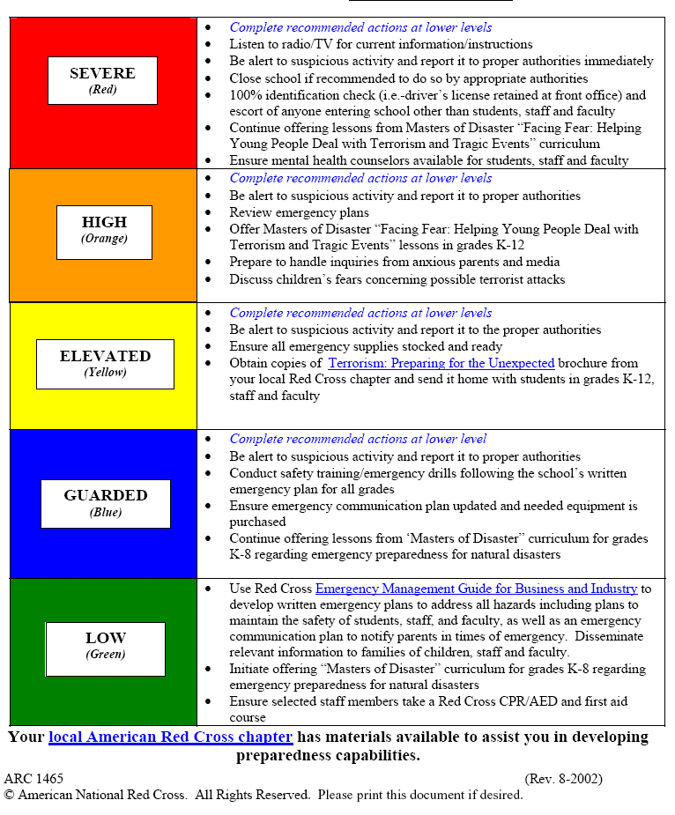
- Depending on the type of attack, standard response protocols will be followed during the events of a terrorist attack.
Suspicious Packages
Some indicators of suspicious packages are as follows:

- Mailed from a foreign country
- Excessive postage
- Rigid or bulky
- Restrictive markings
- No return addresses
- Strange odor
- Lopsided or protruding item
- Oily stains, discolorations, or crystallization on wrapping

If a determination has been made that the package is suspicious:
- Do not open, shake or empty the contents.
- Report the incident to the principal, who may call 911. The dispatcher should be told what you have discovered and what steps you have already taken.
- Keep others away from the package or letter. The principal or designee will keep the package secure.
- Wash your hands with soap and warm water for one full minute or more. Wash your face and then blow your nose. Everyone who handled the mail should do the same.
- Be prepared to meet with law enforcement or emergency personnel.
- List all people who were in the room or area when the suspicious letter or package was recognized. Give this list to police for follow-up investigation and advice. Make a note of who delivered the package to the school.
- If the letter or package is leaking powder, use the following precautions:
  - Do not try to clean up the powder. Cover the spilled contents immediately with a plastic bag, using the bag like a sheet of plastic. Do not remove this cover.
  - Leave the room, close the door or section off the area, and stand by to prevent others from entering.
  - Remain by the sealed area to meet with law enforcement or emergency personnel. Follow their advice concerning personal clean up.

- The U.S. Post Office has developed the following poster describing the warning signs of potentially contaminated mail. It is available at www.usps.com/cpim/ftp/posters/pos84.pdf

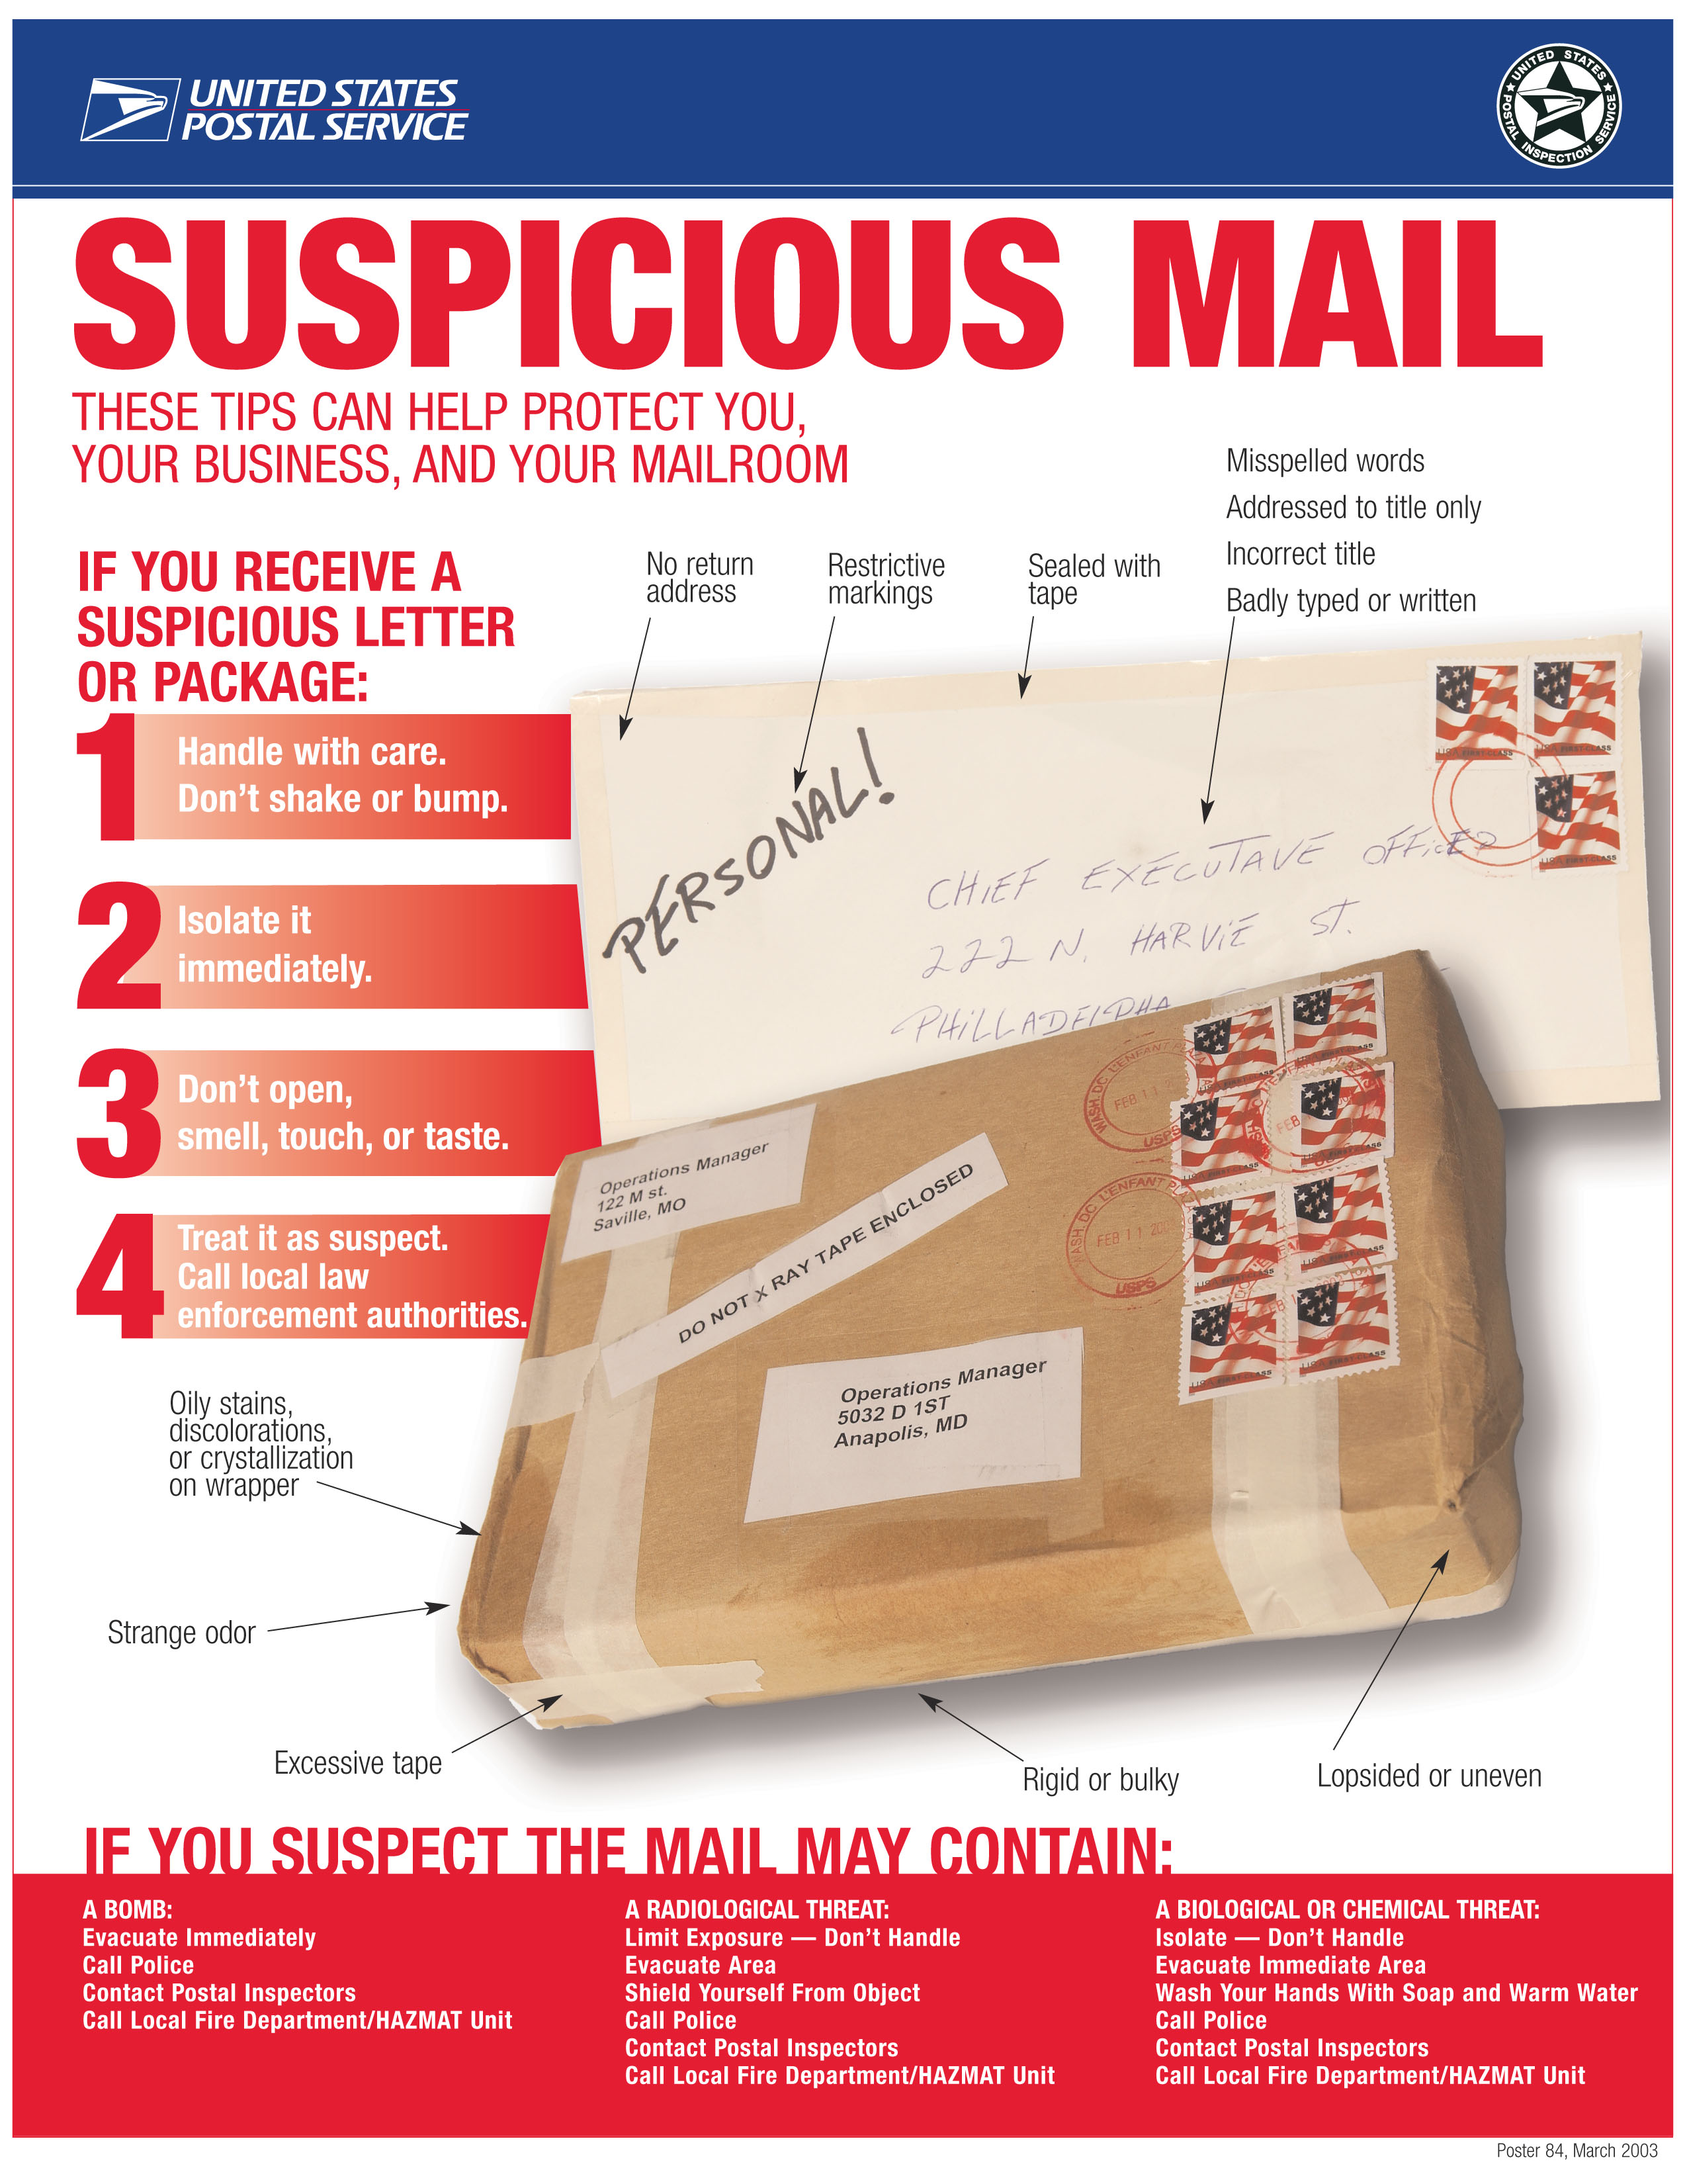

Utility Emergencies
Protocols for utility emergencies are as follows:

- If you smell gas or hear a blowing or hissing noise coming from a utility line or vent, open a window and quickly notify the maintenance staff and administration, before evacuating the building with your students.
- The maintenance staff should turn off the main gas valve, which should be marked in advance with fluorescent tape and an identifier. Once gas has been turned off, it should only be turned back on by a professional.
- If you see sparks or broken or frayed wires, or if you smell hot insulation, the maintenance staff should be notified to turn off the electricity at the main fuse box or circuit breaker.
- Do not step in water in which downed lines or sparks are visible.
- Never touch live wires.
- Do not attempt to rescue a person who is experiencing electrical shock until the power is off.
- If you suspect sewage lines are damaged, avoid using the toilets.
- Do not turn the lights on or off.
- Exit/emergency signs will be lit. Flashlights are available in the emergency kits. Further instructions will be given through megaphones. Maintenance department will notify NTUA if it is related to a gas or electrical emergency. The principal will notify EPA at Agency.
Weather Emergencies
Note: schools lie in locations that are affected by a wide range of weather emergencies. Weather emergencies that may threaten your school should be described here with the appropriate protocols. Resources such as the National Weather Service provide more detailed information relevant to your weather threats.

Protocols for weather emergencies are as follows:

Earthquakes

- Ensure that shelves in the classroom are fastened securely to the walls. Place large or heavy objects on lower shelves. Keep students away from the shelves.
- If an earthquake begins, instruct the children to take cover under a piece of heavy furniture or against an inside wall and hold on.
- School occupants should stay inside. Trying to leave the building is extremely dangerous.
- If outdoors, move into the open, away from buildings, streetlights, and utility wires. Once in the open, stay there until the shaking stops.
- Be prepared for aftershocks. Although smaller than the main shock, aftershocks cause additional damage and may bring weakened structures down.
- Help injured or trapped persons. Administer First Aid when appropriate. Do not move seriously injured persons unless they are in immediate danger of further injury. Call for help.
- Open closet and cupboard doors cautiously.
- Listen to a battery-operated radio or television for the latest emergency information.
- Once secure, stay out of damaged buildings.
- Leave the area if you smell gas or fumes from other chemicals.
- If you smell gas after the earth has settled, instruct children to exit the building take actions per Utility Emergencies, above.
Hurricanes and Flash Floods

- If sufficient warning is given, the entire school community is encouraged to evacuate the area.
- If insufficient warning is given, school occupants should stay at the school if flash floods threaten transportation routes, but not the school itself. Shelter-in-place protocols will be activated.
- Under no circumstance should anyone attempt to drive through flash floods. The road may give way, or the flooding may be far deeper than it appears, causing the vehicle to sink, float, or get stuck.
- Contact Emergency Responders.

Tornadoes

During a tornado, the principal will activate a shelter-in-place alert. In high winds, the greatest threats are roof failure, breaking glass, and flying debris. According to the National Weather Service, the most dangerous locations are generally large rooms with large expansive roofs such as cafeterias, gymnasiums and auditoriums. The collapse of the room’s outer load-bearing wall can lead to the failure of the entire roof.
During this time, school staff should:

- Move children to the lowest level in the school and into interior rooms or interior windowless hallways. All doors should be closed if possible.
- Children should be taken to hallways in center of buildings. Instruct students to sit down along the wall, pull knees up, place head on knees, and put arms/hands over heads. They are to remain in that position until the all-clear is sounded.
- Stay away from windows, glass doors, skylights, and mirrors.
- Keep windows closed.
Note: the school should periodically conduct tornado drills and it should obtain a weather radio that can receive warnings from the National Weather Service. Weather information is also available through television or the Internet at http://www.weather.gov/nwr/
Appendix A:
Map attachments

Off-Site Evacuation Routes:

Nenahnezad Community School to Nenahnezad Chapter House 505-960-9702
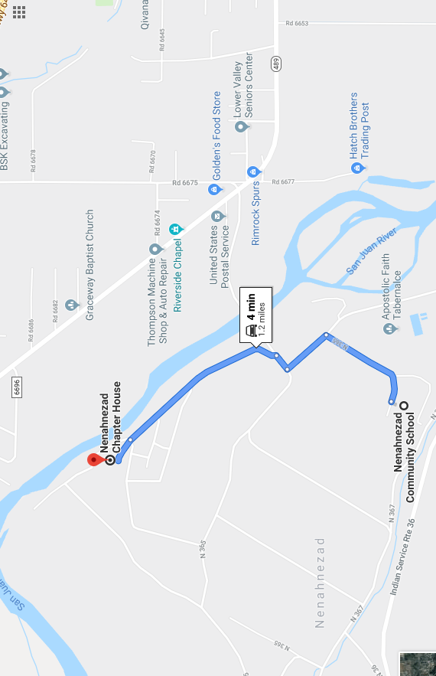

Nenahnezad Community School to Upper Fruitland Chapter 505-960-5032
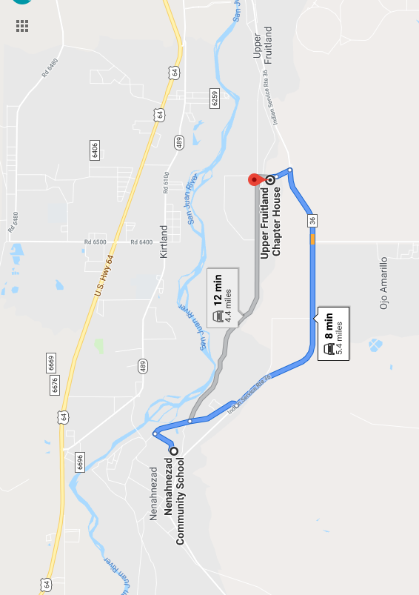
Nenahnezad Community School to Ojo Elementary School 505-368-4984
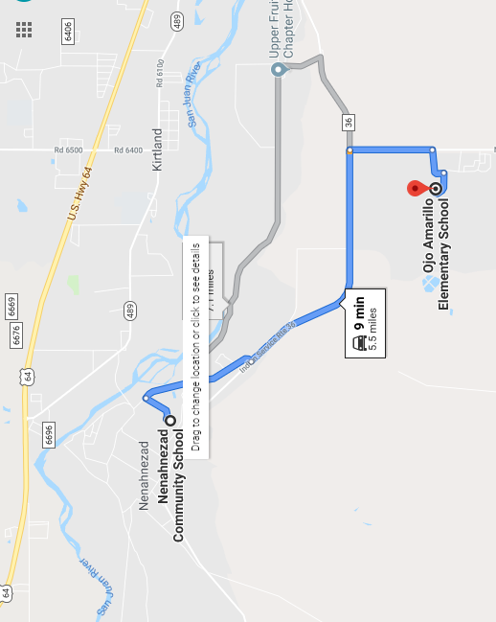

On-Site / Building Evacuation Routes:

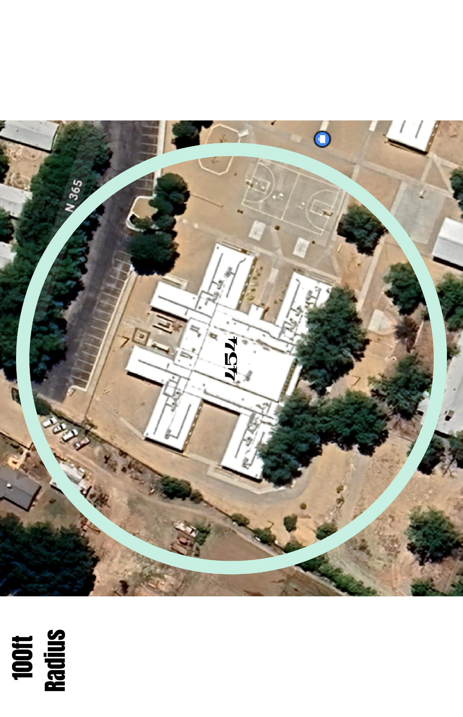
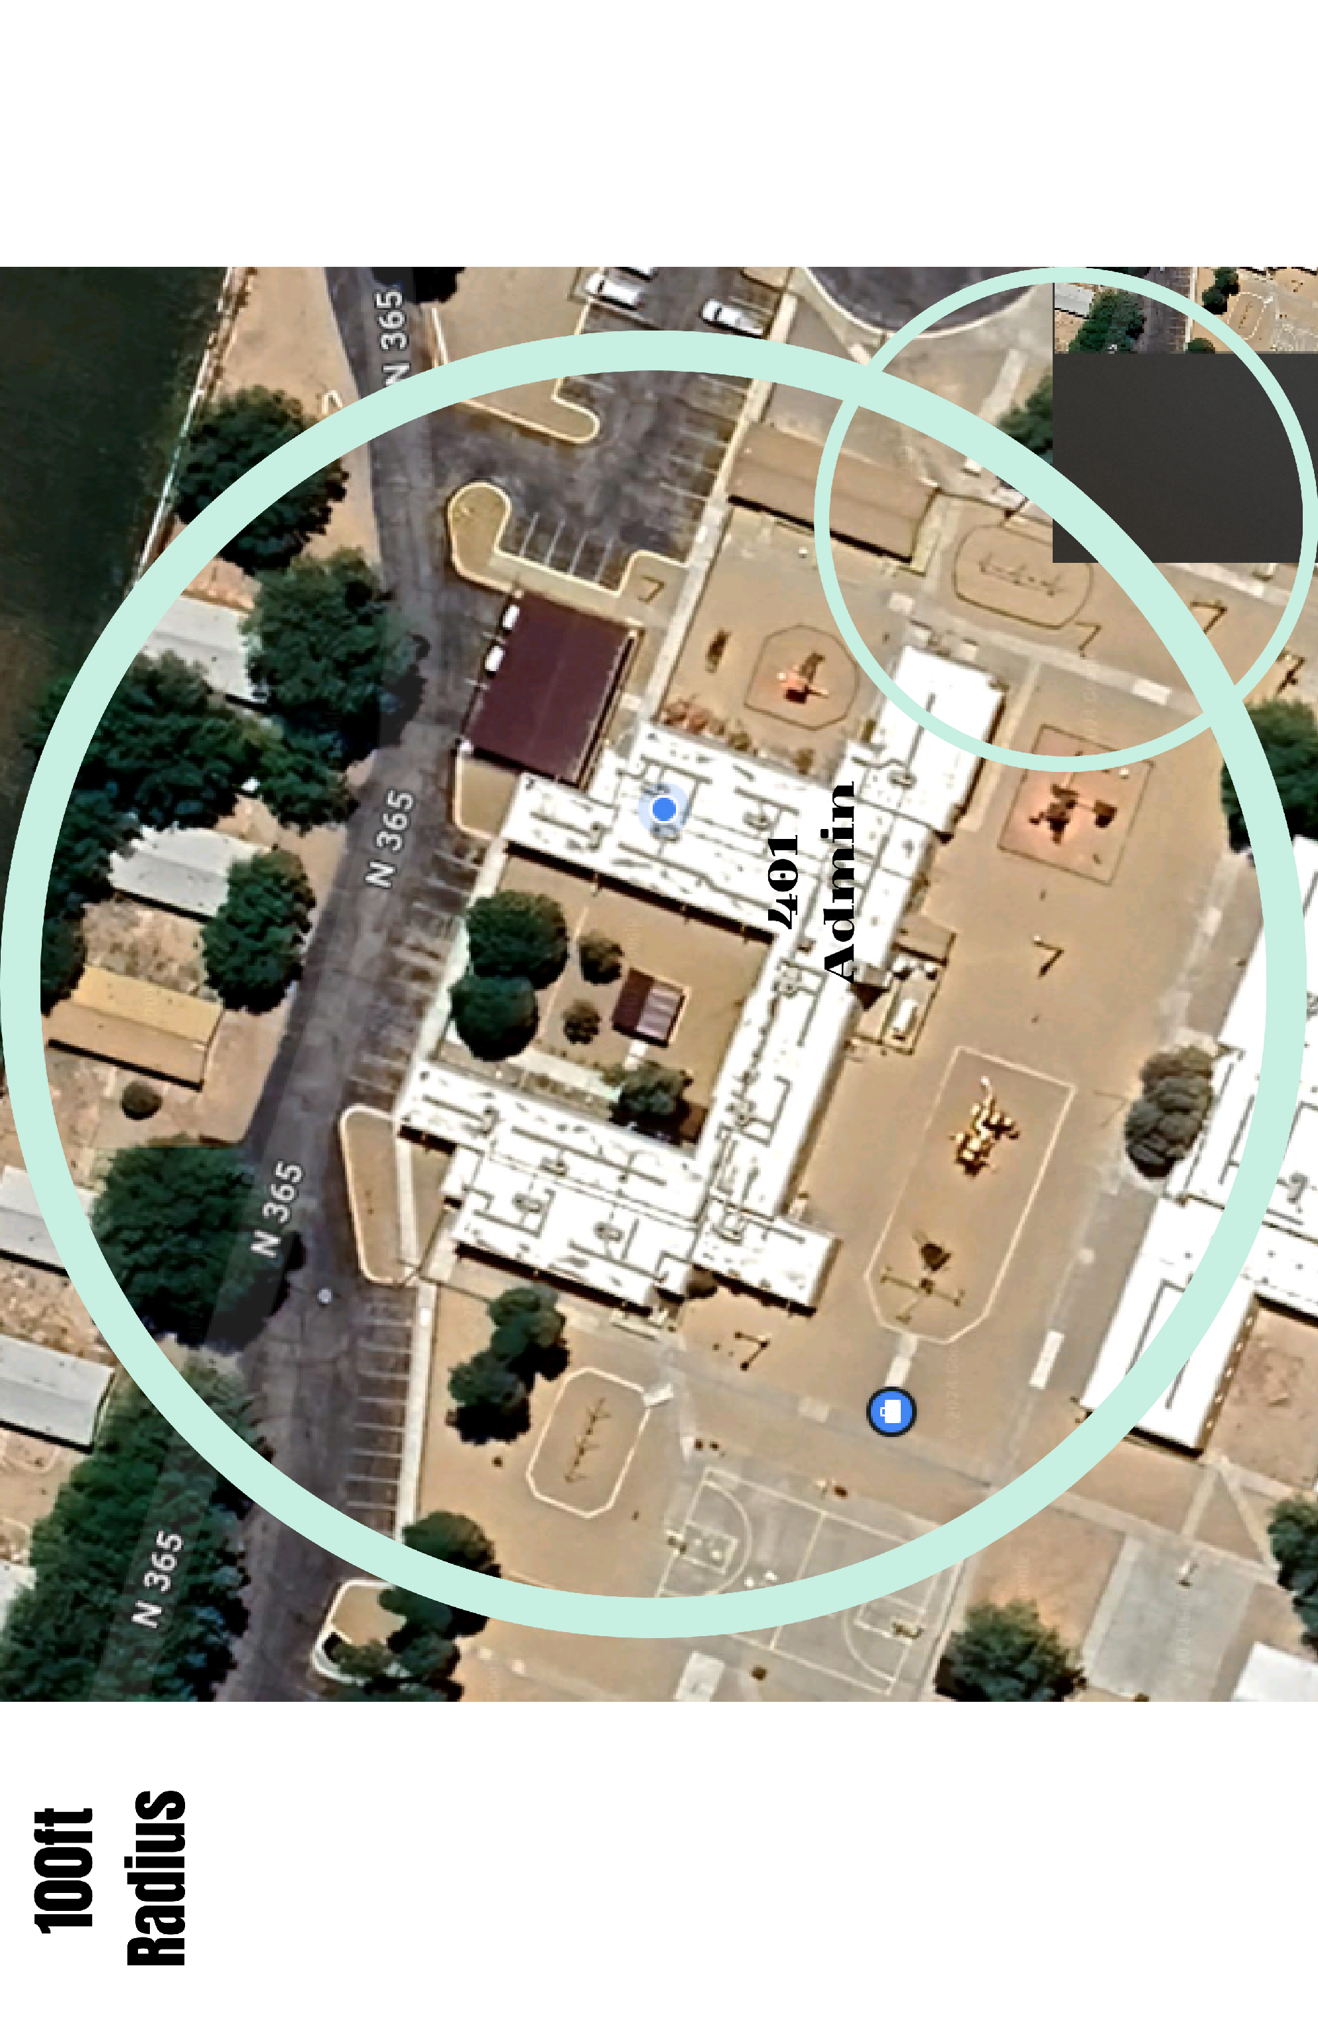
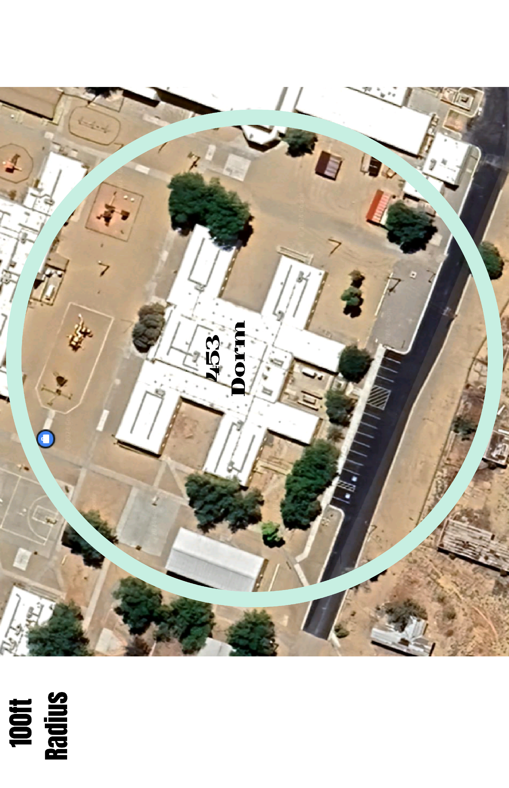
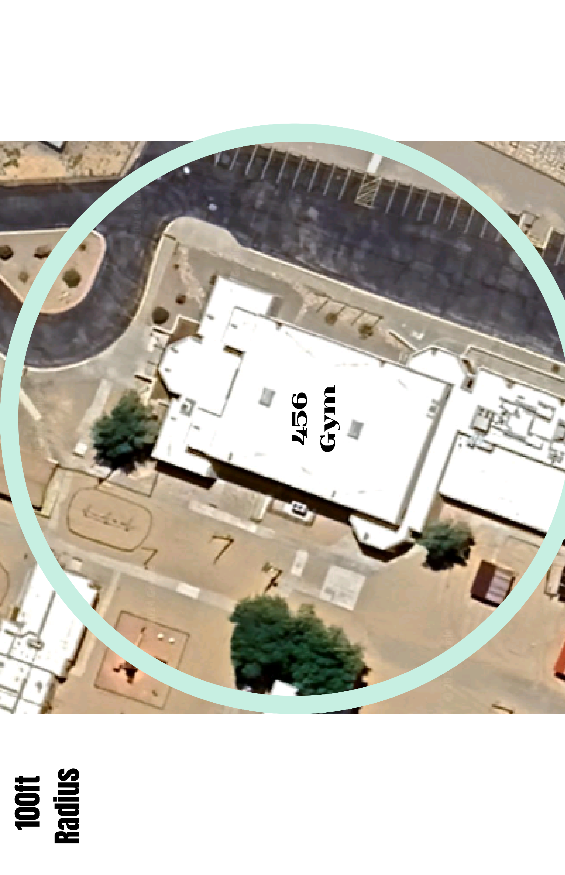
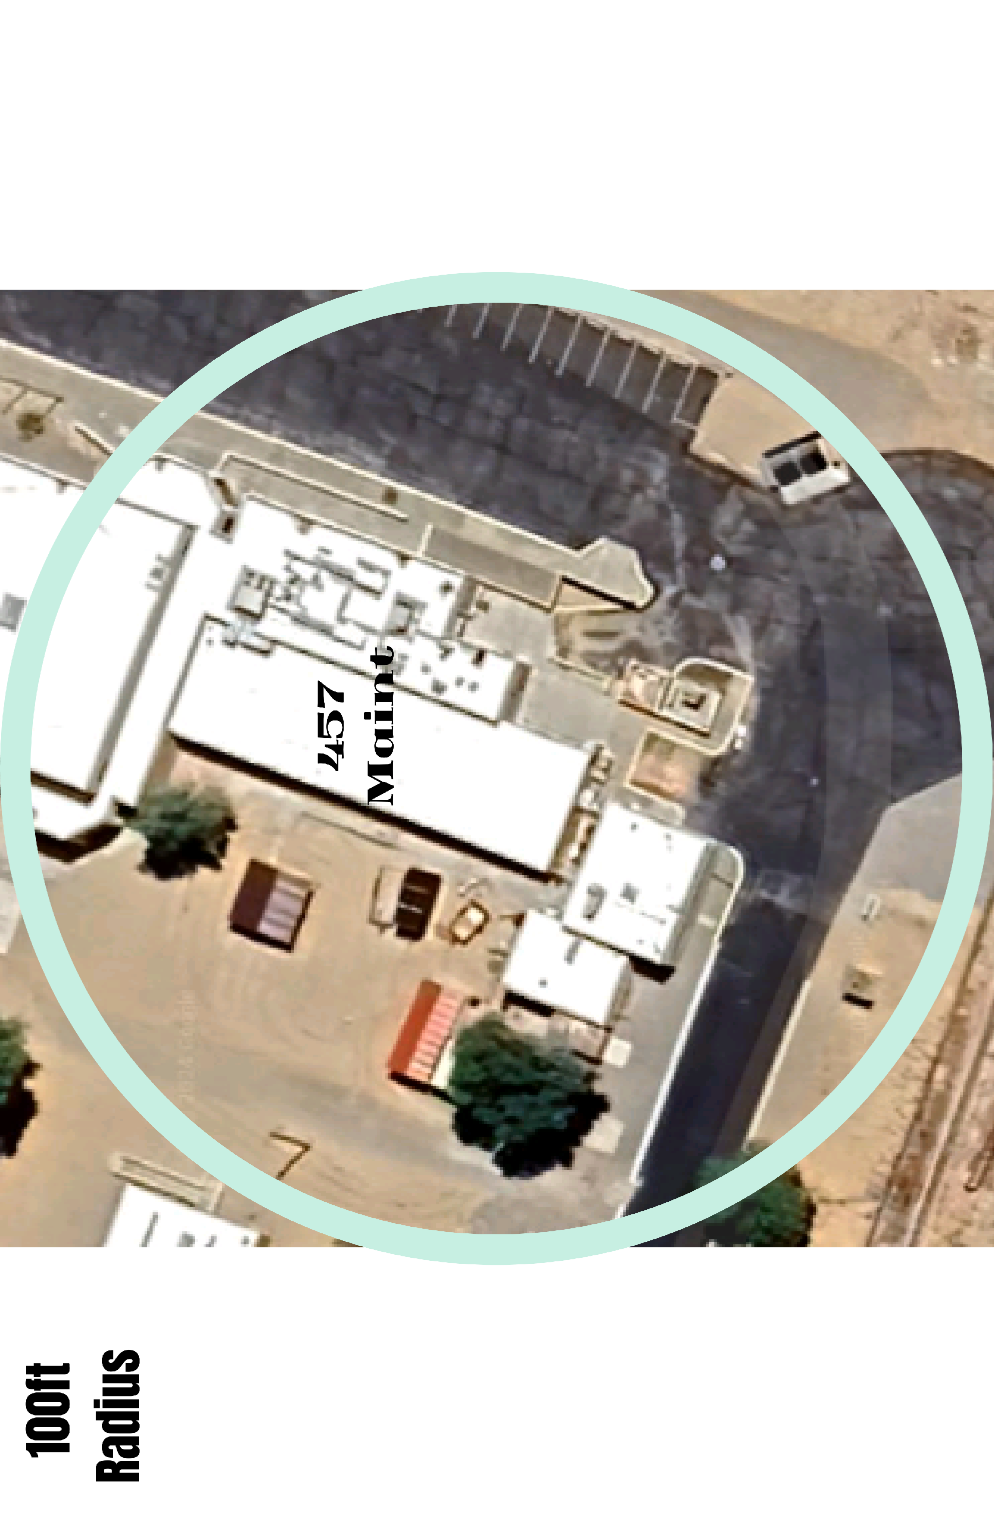
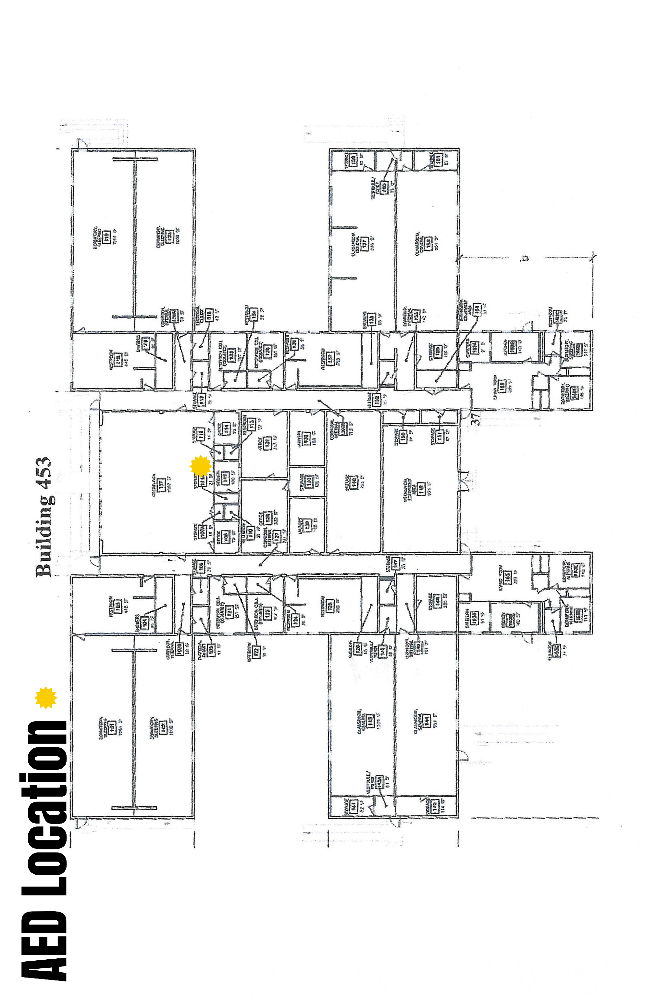
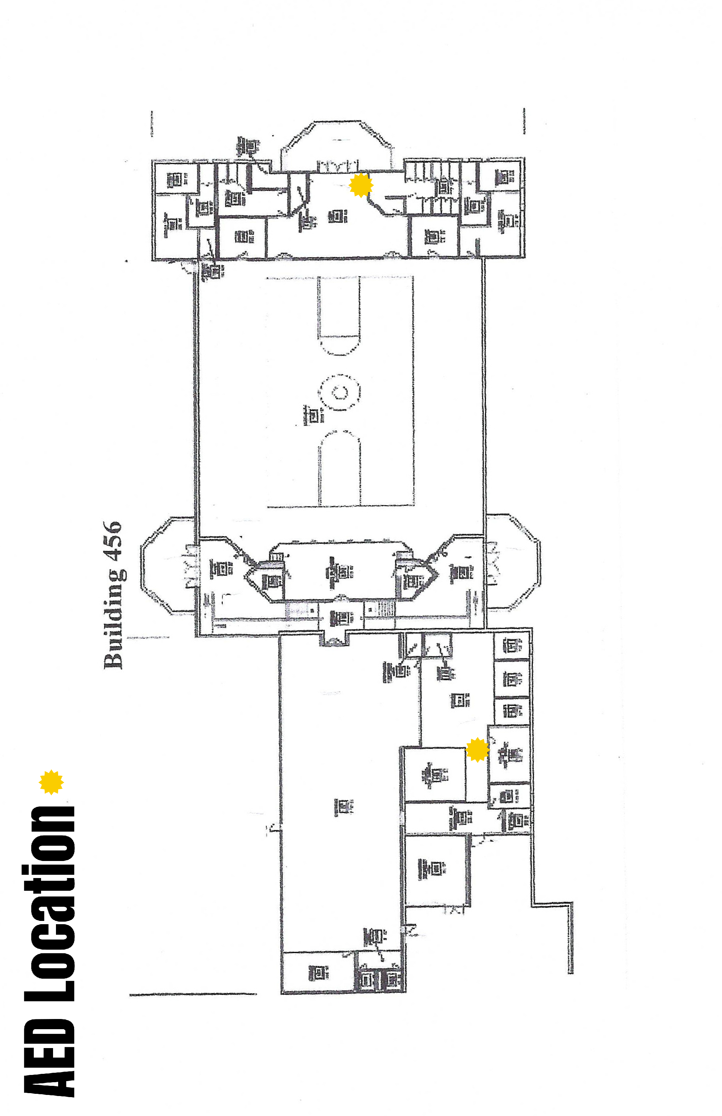
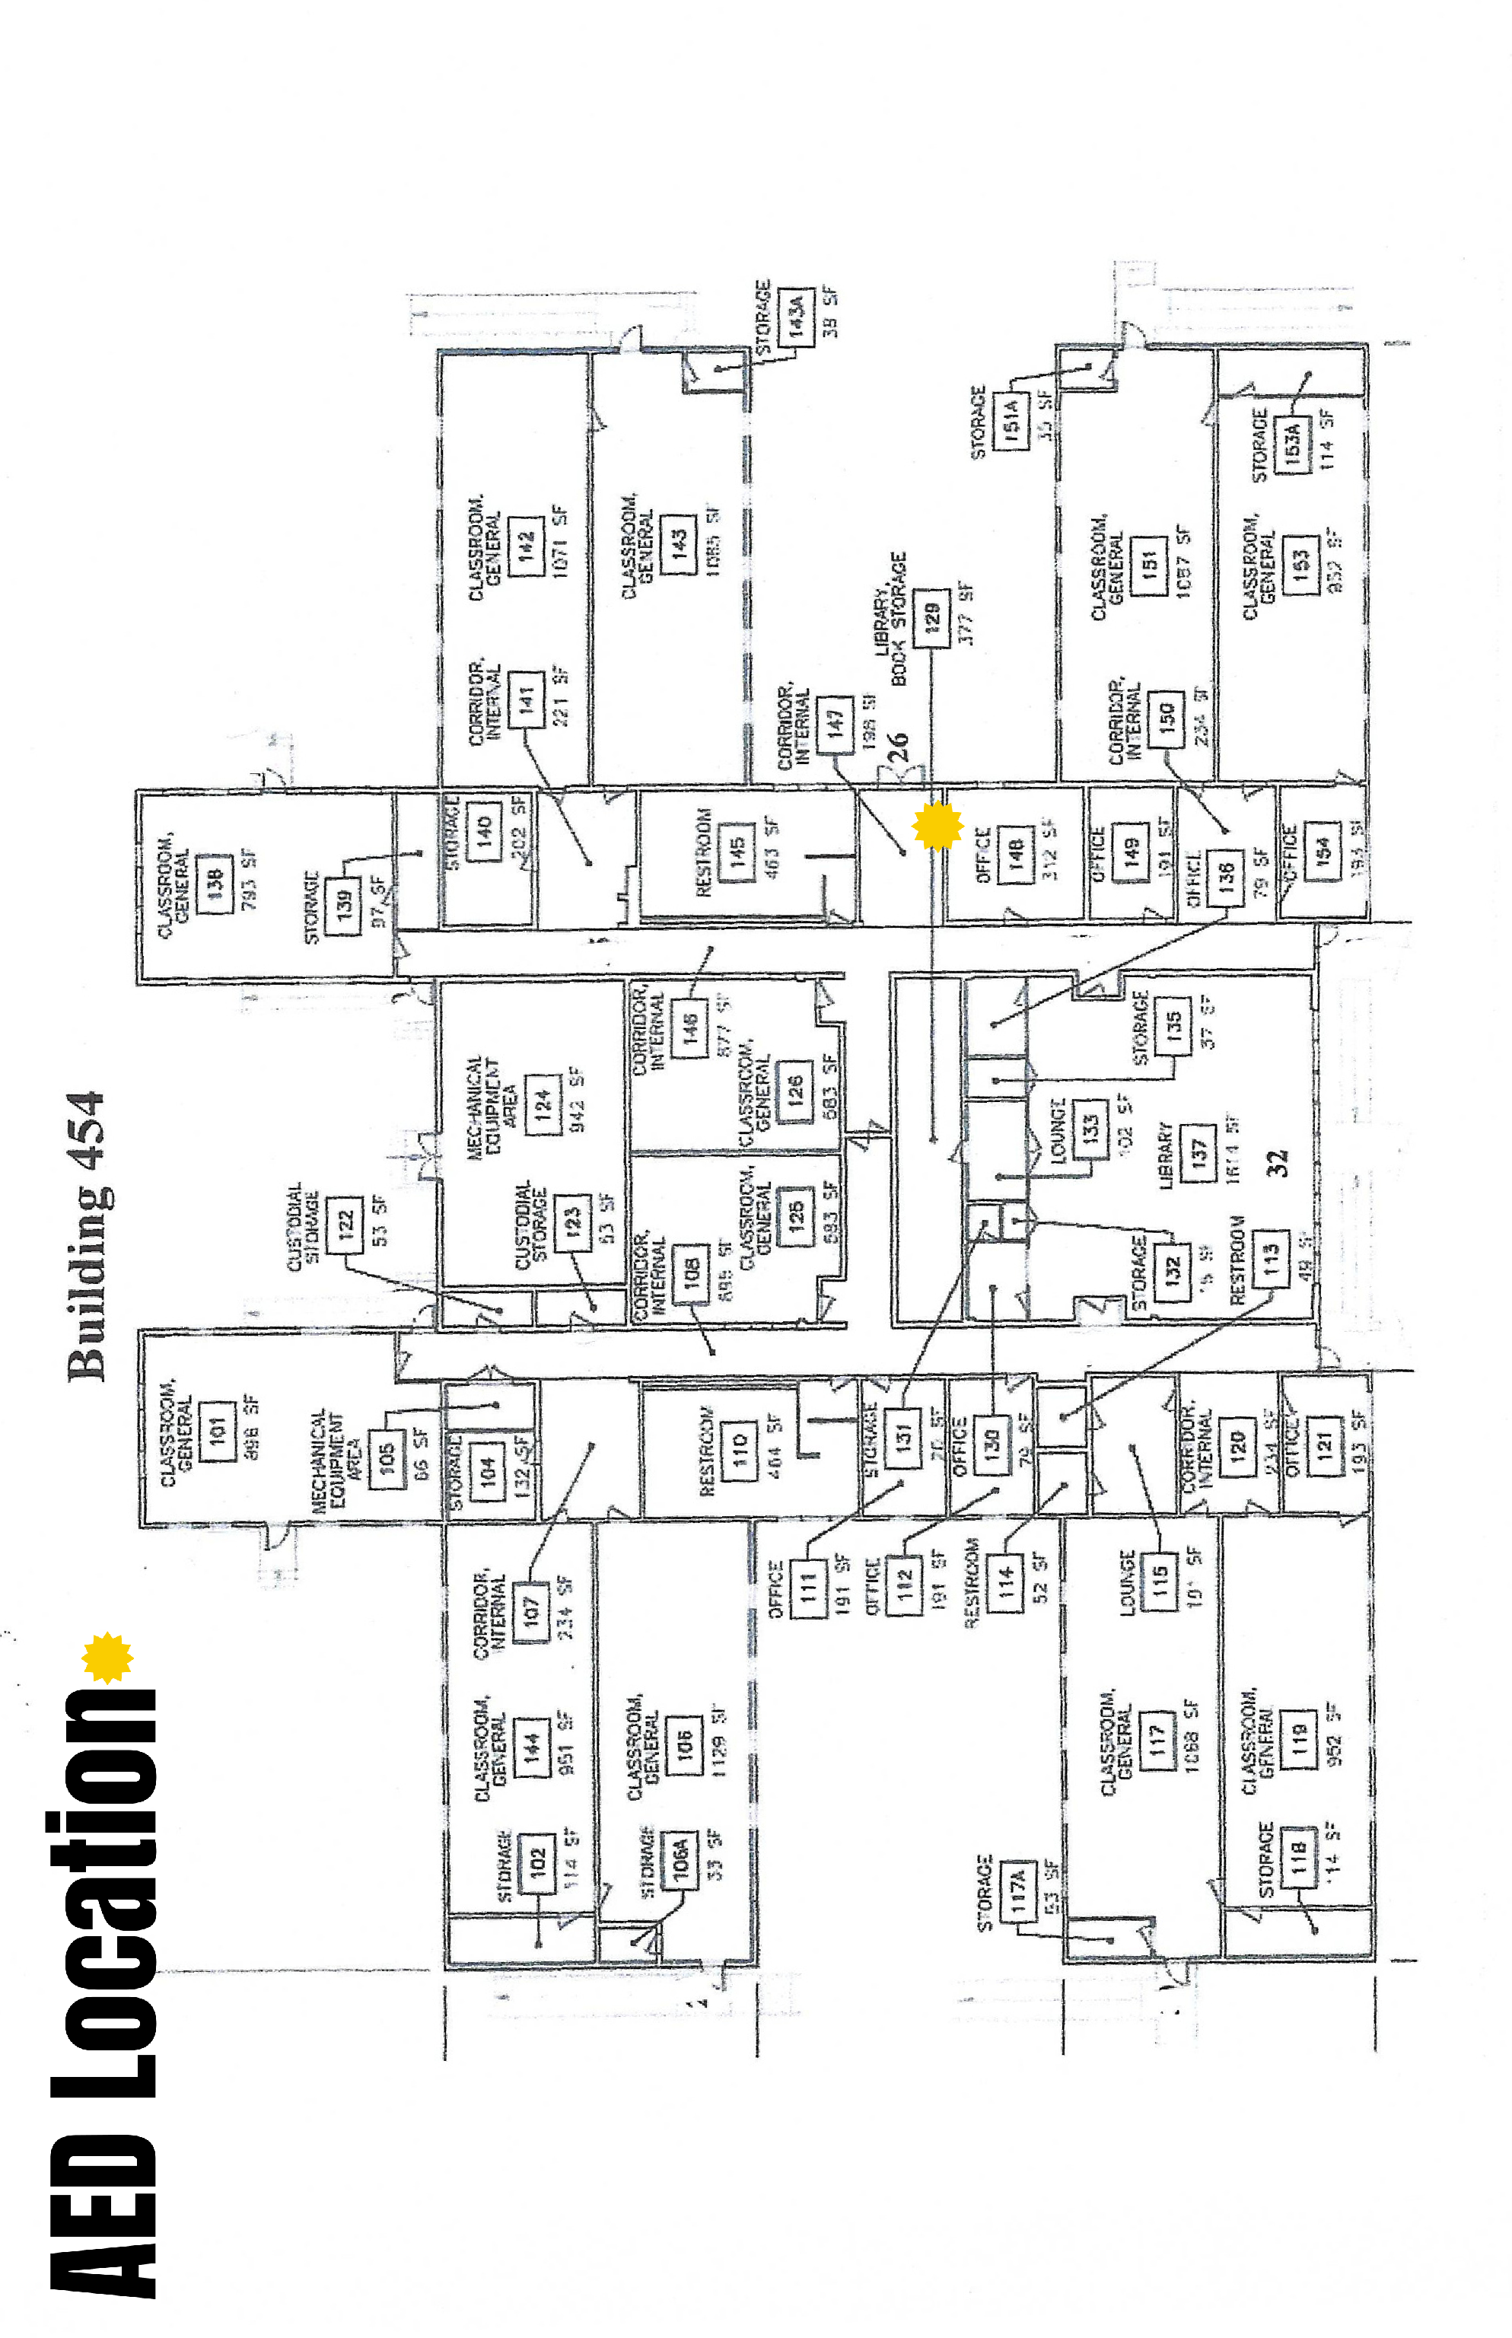
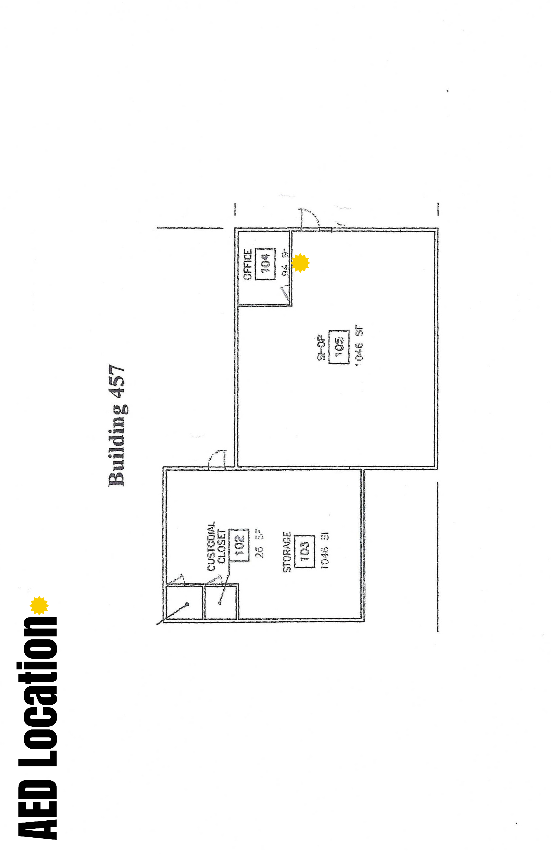
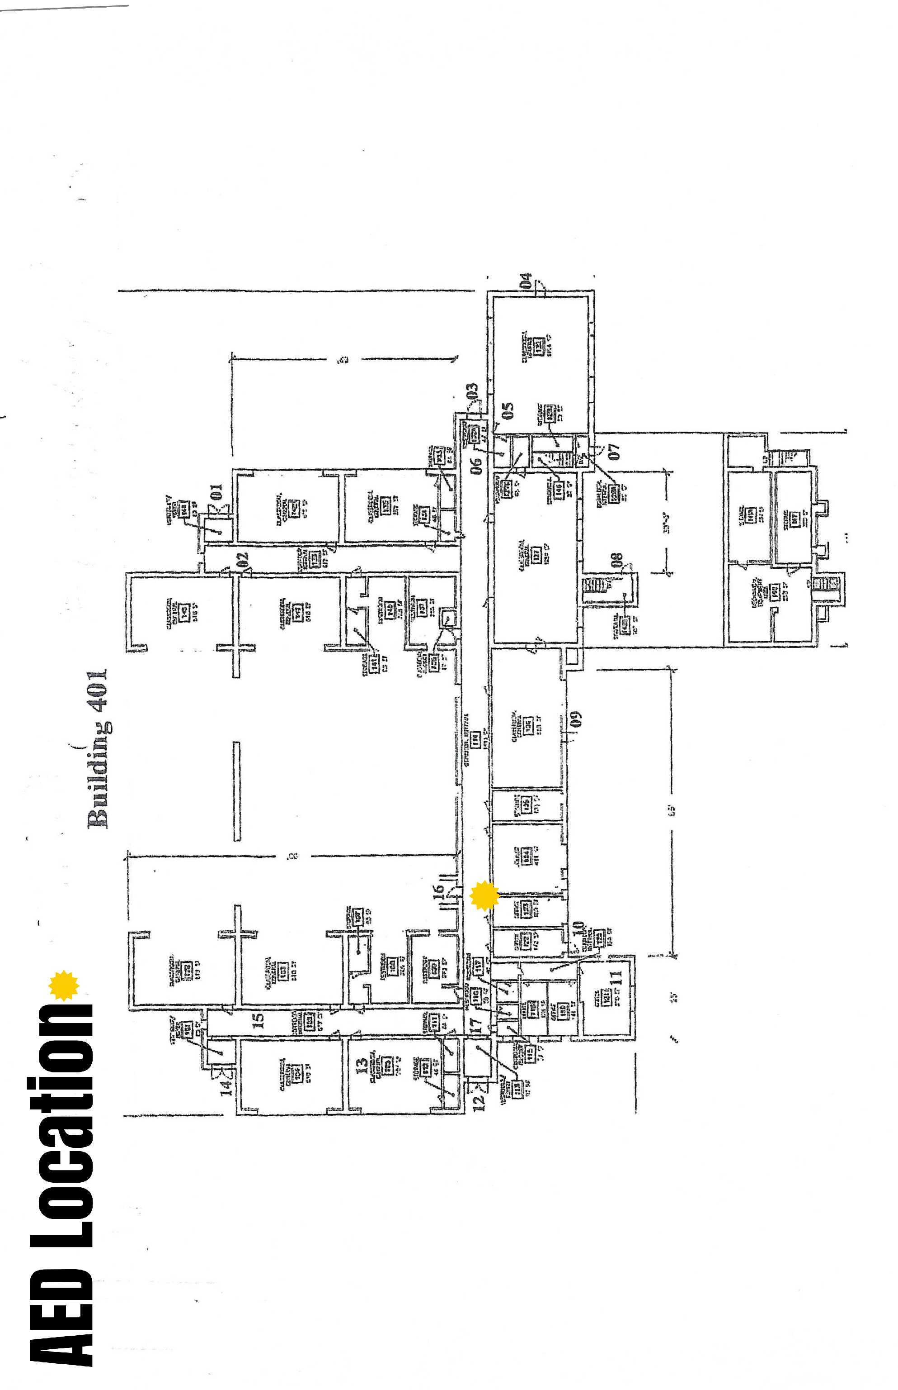
Media Staging Location:
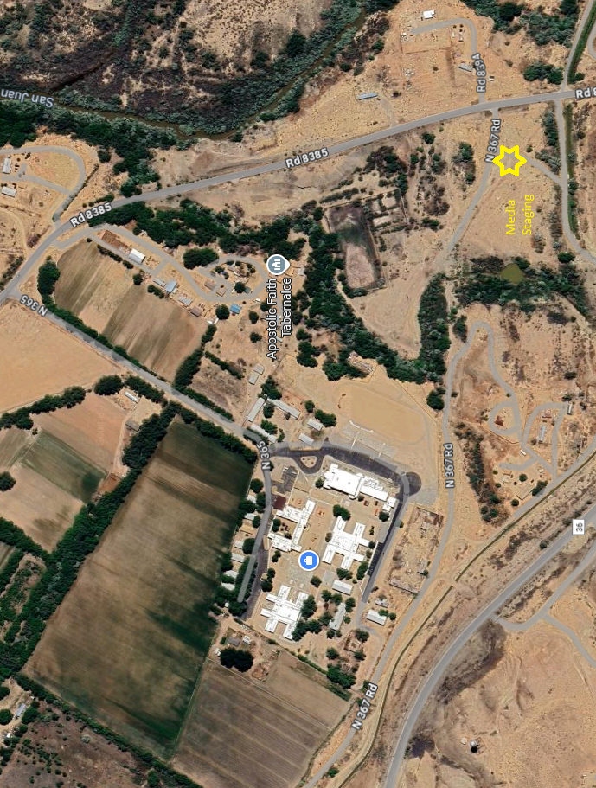
Appendix B:
Outdoor Air Quality

5-3-1 Rule:

The 5-3-1 method is a valuable tool for assessing air quality during wildfire events, particularly in rural communities and tribal schools. This approach can be incorporated into the Continuity Of Operations Plan (COOP) to enhance communication and decision-making. By including a chart that outlines the method, school leaders can quickly reference visibility guidelines and determine appropriate responses based on current conditions. This ensures everyone is equipped to make informed choices that safeguard health and maintain operational continuity.

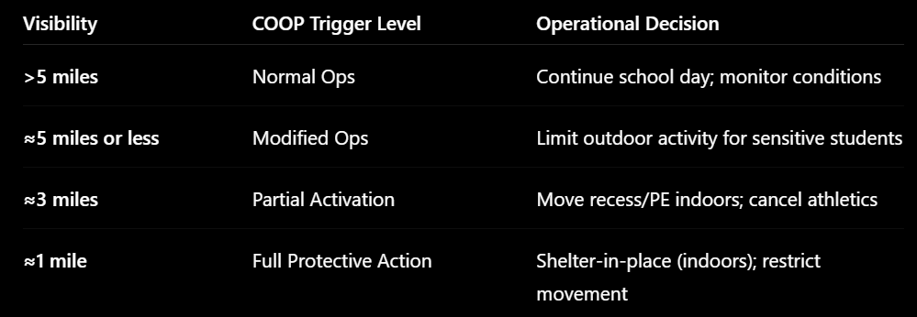

This table serves as a practical tool to prompt proactive measures, such as transitioning indoors before air quality worsens, activating indoor air purifiers, and modifying daily routines—for instance, relocating outdoor recess indoors.

When it comes to emergency management, each team member plays a distinct role: facilities staff are responsible for conducting visibility checks, the principal oversees operational decisions for the school, and teachers implement necessary adjustments, including shifting to virtual learning as needed.

Additionally, external communication is crucial; this involves informing parents about current air quality conditions and keeping staff updated on procedures to ensure the continuity of school operations.

Changes to any typical school day will be determined by the principal of delegate and communicated to all stakeholders using normal communication methods.

